C:\Users\42912\Desktop\New Linear logo\Colour logo\DCC_CMYK_tiff.tif

Grangegorman Filtered Permeability Trial – Report

4 January 2021

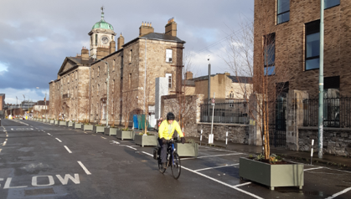

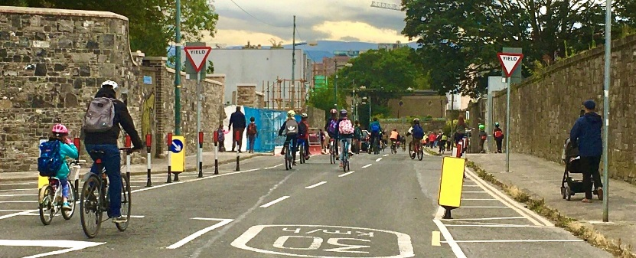

Contents

[INTRODUCTION 4](#_Toc60670627)

[Covid-19 and Impacts on Mobility in the City 4](#_Toc60670628)

[Dublin City Covid Mobility Programme 4](#_Toc60670629)

[Background 6](#_Toc60670630)

[Grangegorman Area 6](#_Toc60670631)

[Grangegorman Urban Quarter 7](#_Toc60670632)

[Transport in Grangegorman Urban Quarter 9](#_Toc60670633)

[Supporting Documents 11](#_Toc60670634)

[Dublin City Development Plan 2016-2022 11](#_Toc60670635)

[Dublin City Council Corporate Plan 2015-2019 11](#_Toc60670636)

[Technical Documents 11](#_Toc60670637)

[Interim Mobility Intervention for Grangegorman Lower 12](#_Toc60670638)

[Genesis of Trial 12](#_Toc60670639)

[Design 13](#_Toc60670640)

[Trialled Option 13](#_Toc60670641)

[Trial Design Details 14](#_Toc60670642)

[Road Closure to through Motor Vehicles 14](#_Toc60670643)

[Access Restrictions and Left/Right Turning Bans 15](#_Toc60670644)

[Pedestrianised Street (Except Access and Cyclists) 15](#_Toc60670645)

[Implementation and Duration of Trial 17](#_Toc60670646)

[Data Collection and Analysis 18](#_Toc60670647)

[Motor Car Availability in Grangegorman 18](#_Toc60670648)

[Commuting in Grangegorman 19](#_Toc60670649)

[Traffic Surveys 20](#_Toc60670650)

[Mode Share 20](#_Toc60670651)

[Vehicular Speeds 23](#_Toc60670652)

[Observed Impacts of Trial 26](#_Toc60670653)

[Positive Impacts 26](#_Toc60670654)

[Negative Impacts 27](#_Toc60670655)

[Consultation 28](#_Toc60670656)

[Pre-Implementation 28](#_Toc60670657)

[Post-Implementation 28](#_Toc60670658)

[Consultation Feedback 31](#_Toc60670659)

[NTA / Busconnects 31](#_Toc60670660)

[Public Feedback 31](#_Toc60670661)

[Overview of Feedback 31](#_Toc60670662)

[Support 32](#_Toc60670663)

[Concerns 33](#_Toc60670664)

[Schools Consultation 37](#_Toc60670665)

[Summary of Feedback 40](#_Toc60670666)

[Conclusion and recommendation 41](#_Toc60670667)

[Appendix A 43](#_Toc60670668)

[Appendix B 46](#_Toc60670669)

[Appendix C 53](#_Toc60670670)

[Alternative Options which were deemed not appropriate 53](#_Toc60670671)

[Option 1 53](#_Toc60670672)

[Option 2 54](#_Toc60670673)

[Option 3 56](#_Toc60670674)

[Option 4 57](#_Toc60670675)

[Option 5 & 6: 58](#_Toc60670676)

[Appendix D 59](#_Toc60670677)

[Consultation Letters 59](#_Toc60670678)

[Appendix E 61](#_Toc60670679)

[Twitter & Facebook Posts And Statistics 61](#_Toc60670680)

[Twitter 61](#_Toc60670681)

[Facebook 63](#_Toc60670682)

[Appendix F 67](#_Toc60670683)

[Collisions 67](#_Toc60670684)

[Appendix G additional comments captured from schools surveys 69](#_Toc60670685)

# INTRODUCTION

## Covid-19 and Impacts on Mobility in the City

The Covid-19 pandemic has affected all our lives and the way in which we work, socialise and communicate. It also has had enormous impacts on our transport system, radically reducing travel levels and likely to alter our patterns of movement for some time to come.

During the period of maximum restrictions, when all but essential workers were required to stay at home, there were, not unexpectedly, dramatic declines in the numbers of people travelling each day. Car traffic fell to about 30% of pre-Covid levels, bus usage on city services dropped by 90% and rail usage reduced by about 97%.

As the restrictions were eased with workplaces, schools and shops re-opening, the numbers of people travelling and moving around the city started to increase again. More space was required to be allocated to social distancing and to supporting shops and businesses operating in the new environment. In addition the government advice was to walk or cycle where possible and so there is a requirement on DCC to try to facilitate people following this advice and ensure that walking and cycling is as safe as possible.

The recent return to level 5 lockdown and the imposition of the 5 km rule and the reduction in capacity on public transport once again emphasise the need for DCC to be providing these safe alternatives to private car use.

In our most recent analysis, from November of 2019, 116,287 people travelled into the city centre by public transport during the 7am to 10am peak period, representing just over half of the total numbers travelling to the city centre during this period. With a reduced public transport capacity, only about 30% of this number will be able to use buses, trams and rail for these journeys in the coming months until restrictions are eased again.

To facilitate these new patterns of travel, some reallocation of road space will need to be introduced on many streets. These changes will also have to be considered in conjunction with social distancing requirements, which means that changes are needed to various footpaths and public areas to meet these requirements and optimise the use of the space available. In addition, there is a need to consider the needs of businesses, many of which may require additional external space to operate successfully. There is a need to implement these changes in an integrated, co-ordinated way.

## **Dublin City Covid Mobility Programme**

In May 2020, Dublin City Council in conjunction with the NTA published the paper “Enabling the City to Return to Work, Interim Mobility Intervention Programme for Dublin City” which sets out a framework of proposals to address the new and urgent needs which have emerged as a result of the Covid-19 Public Health Emergency in Ireland.

The overall aim of the programme is enabling the city to return to work, to enable retail and leisure activities to restart and allow people to visit family and friends and, in time, schools and colleges to reopen all in line with government guidelines and timescales.

The programme initially looks at the links from the nearer urban villages to the city centre and within the city centre it looks at how a more pedestrian, cycling and public transport friendly centre can be set out. This is very much a “live” programme and over the next number of weeks, additional areas of the city and proposals will be added. The gradual reopening of the economy and society as set out by the Government strategy will present new challenges as it unfolds, so this must, of necessity, be a live programme, the implementation of which will be clearly evident on the ground across Dublin City over the coming months.

The goal of this programme, in essence, is to allow the city to function under the new arrangements arising from the Covid-19 Public Health Emergency, both in terms of providing space for safe movement plus business activities, and in accommodating the changed transport patterns.

At the heart of this plan are the following high-level aims:

* To ensure safe access to and movement within Dublin City for all users;
* To provide sufficient movement capacity to cater for the changed travel patterns; and
* To support the economic recovery of the city and the region.

These high-level aims have been translated into transport-specific objectives as follows:

* To improve pedestrian safety through the provision of additional space for movement and enhanced pedestrian areas;
* To enable more people to cycle by providing safer cycling facilities;
* To provide additional space at many bus stops in order to facilitate social distancing while waiting;
* To provide additional pedestrian space outside shops and restaurants to allow for social distancing and allow the retail and restaurant sector to operate in line with government restrictions.

The measures developed in response to these objectives are being introduced to respond to a new and unprecedented emergency caused by the Covid-19 pandemic. They are being implemented on a temporary basis to respond to the urgent and immediate needs of the city. They will be reviewed periodically to assess their effectiveness and, because of their nature and type of implementation, can be modified as needed to respond to changing needs and requirements.

# Background

## Grangegorman Area

The Grangegorman Area is bounded by North Circular Road to the north, Phibsborough Road/ Constitution Hill/ Church Street to the east, Brunswick Street North to the south, and by Manor Street/ Prussia Street to the west (Fig. 1). The area use is primarily residential, with mixed-use (i.e. residential and educational) along Grangegorman Lower. The area is serviced by educational facilities including primary schools and the TU Dublin Campus, the Bring Recycling Centre and health care facilities.

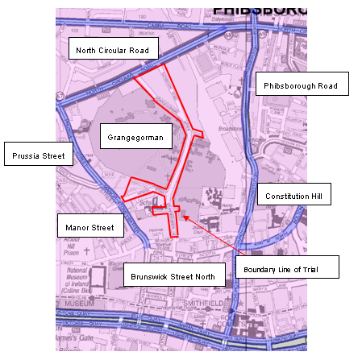

Figure 1: Map showing Grangegorman bounded by Arterial Streets and Boundary Line of Trial

## Grangegorman Urban Quarter

The new Grangegorman Urban Quarter is an education, health and community development by the Grangegorman Development Agency (GDA) for Technical University Dublin (TU Dublin) and the Health Service Executive (HSE) (Fig.2). The movement of pedestrians, cyclists and Luas commuters in this area is set to increase considerably in 2021 with the re-opening of TU Dublin facilities and the opening of the Central and East Quads, and the Lower House. While this has been hampered by the current COVID restrictions, the number of students on campus is expected to commence increasing on a phased basis. The Eastern Quad building will accommodate the approximately 3,500 additional TU Dublin students representing an increase on the 1,200 students currently using the campus since 2014. The Central Quad building will accommodate another 6,500 students and an additional 800 staff. When fully completed, TU Dublin will accommodate over 20,000 staff and students.

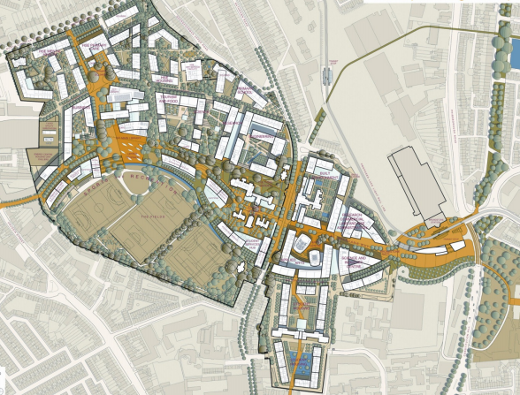

**Grangegorman Urban Quarter / TU Dublin Campus**

Grangegorman Lower

Figure 2: Grangegorman Lower divides the Grangegorman Urban Quarter/TU Dublin Campus

The Broadstone Pedestrian plaza which is currently forecast to open in early 2021 will become a key pedestrian East to West (and vice-versa) linkage between the Broadstone Luas Station to the campus and will also provide an excellent pedestrian link from Stoneybatter to the city centre (Fig. 3).

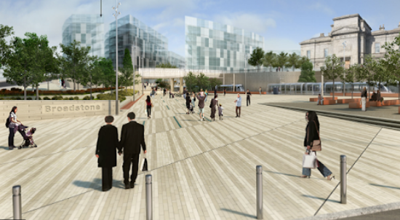

Figure 3: Artist’s impression of the Broadstone Pedestrian Plaza

The Urban Quarter is divided by Grangegorman Lower and this division will be mediated by carrying a section of the Broadstone Plaza across the existing roadway (Fig. 4).

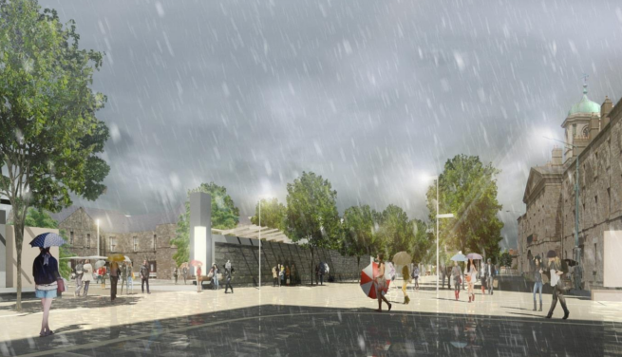

Figure 4: Artist’s impression of the Broadstone Pedestrian plaza on Grangegorman Lower

It is intended in the Grangegorman Urban Quarter Masterplan that this section of Grangegorman Lower would be a shared surface where pedestrian (including mobility impaired) and cyclist movement and access are the priority throughout.

## Transport in Grangegorman Urban Quarter

The new year (2021) city wide intake of students, 75% of whom are commuters, will represent a dramatic increase in student numbers at Grangegorman and will place a significant additional demand on the City’s transport network. While Universities are in general providing online tuition, it is expected that this will change over the next months as Government restrictions are eased.

The GDA Strategic Plan (2011) and the Grangegorman Planning Scheme (2012) which, amongst a number of movement related aims and objectives for the Grangegorman Urban Quarter, set out to ‘ensure a high level of access, particularly in terms of public transport and pedestrian and vehicular linkages to the surrounding area’. The principles of accessibility by sustainable modes as set out in the Strategic Plan and Planning Scheme were developed further and more explicitly in the Grangegorman Area - Mobility Management Plan (2011) and the Draft Grangegorman Mobility Management Plan (2014).

The ambitious future modal split targets (Fig. 5), as agreed with Dublin City Council, Grangegorman Development Agency including TU Dublin, medical, commercial and other educational uses such as a relocated primary school propose that public transport will be the main mode of travel contributing approximately 60% of total trips. Bus services will provide approximately 33% for all users, this is based on the existing TU Dublin mode share of approximately 40% for buses. The target for cycling is 15%, while walking is to provide 12% of all trips.

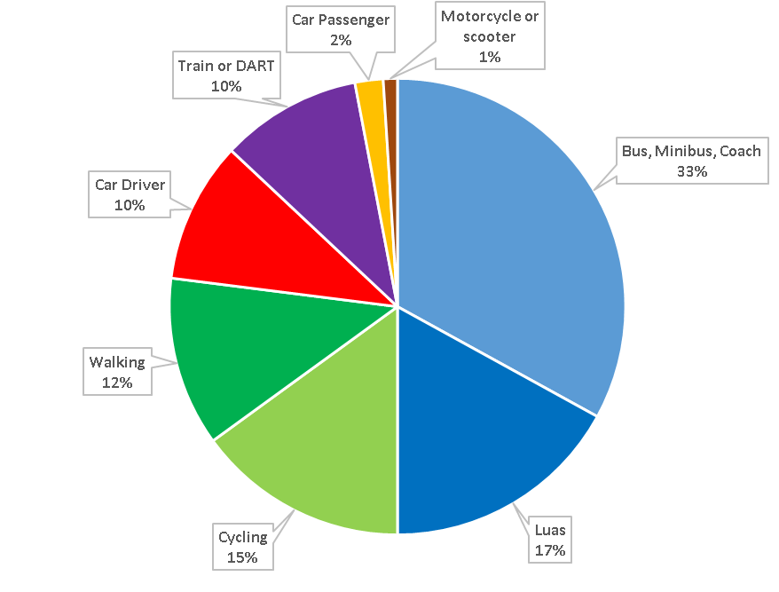

Figure 5: Grangegorman Mode Share Targets (Source: Draft Grangegorman Mobility Management Plan (2014))

The completion of the Central and Eastern Quad buildings will significantly influence future travel patterns and behaviour for the Urban Quarter through the implementation of mobility management measures to encourage the use of sustainable modes.

Whilst the timing of the reduction in the capacity of the public transport network is unfortunate, TU Dublin and Grangegorman Development Agency have stated that they support the objectives of the Dublin City Covid Mobility Programme to provide the basis for the rapid delivery of enhanced facilities for the modes of walking and cycling which will take on an increased role in servicing the access needs of Grangegorman.

The transport-specific objectives from the Dublin City Covid Mobility Programme are aligned to the needs of Grangegorman to improve pedestrian safety through the provision of additional space for movement and enhanced pedestrian areas, and to enable more people to cycle by providing safer cycling routes (Fig. 6).



Main Pedestrian & Cycling Routes

**Grangegorman Urban Quarter / TU Dublin Campus**

Location of Filtered Permeability Measures

Grangegorman Lower

LUAS Station

Broadstone Pedestrian Plaza

Figure 6: Main Pedestrian & Cycle Movements in the Grangegorman Urban Quarter (Grangegorman Lower divides the Urban Quarter)

Accordingly, the Grangegorman Filtered Permeability Trial aims to create a safer space for local residents and prepare for the arrival of thousands of pedestrians and cyclists expected at TU Dublin in 2021 as restrictions ease. As such, the positive impacts of the trial cannot be fully realised until the TU Dublin campus and Broadstone Pedestrian Plaza open, and when traffic patterns return to normal following the gradual lifting of Covid-19 travel restrictions.

## Supporting Documents

### Dublin City Development Plan 2016-2022

* The core strategy will guide development in both policy and spatial terms. Delivered together, these priorities represent an integrated and holistic approach to the delivery of essential infrastructure and services within an over-arching sustainable framework.
* In order to create a more sustainable city, the development plan, in accordance with national policy, places emphasis on the need for a modal shift from motorised private modes of transport towards public transport, cycling and walking
* Support the continued development of a quality, affordable and accessible movement system within the city prioritising walking, cycling and quality public transport which serves both the needs of local neighbourhoods and the economy of the city and the health and well-being of all.
* The creation and nurturing of sustainable neighbourhoods, which are designed to facilitate walking and cycling, close to public transport insofar as possible, and a range of community infrastructure, in quality, more intensive mixed-use environments

### Dublin City Council Corporate Plan 2015-2019

* The place to live (GOAL 4): To deliver improved quality of life and social inclusion throughout the city by providing sustainable neighbourhoods, supported by a range of services and connected by good public transport and green infrastructure.
* The place to live (GOAL 6): To promote healthy living and the recreational use of Dublin’s unique natural amenities while protecting the environment and building resilience to cope with climate change.

### Technical Documents

* Design Manual for Urban Roads and Streets (DMURS)
* National Cycling Manual
* Traffic Management Guidelines
* Traffic Signs Manual
* Greater Dublin Area (GDA) cycle network plan.

\*Note this is not an exhaustive list

# Interim Mobility Intervention for Grangegorman Lower

Introduction of safe pedestrian and cycle facilities along with low trafficked streets in Grangegorman has been a continuing objective of DCC and the GDA and is part of the Grangegorman Urban Quarter Masterplan. In response to the immediate impact on public transport capacity due to Covid-19 restrictions, a filtered permeability temporary scheme at Grangegorman was implemented as part of the suite of Covid Mobility Measures that were undertaken by rapid deployment across the City in order to optimise mobility during the pandemic.

Dublin City Council propose to deliver the filtered permeability scheme in two stages:

1. Immediately creating a low traffic neighbourhood with a temporary scheme (complete).
2. Consideration for development of a permanent scheme, which will be informed by engaging with the community and learning lessons from the temporary scheme.

## Genesis of Trial

Grangegorman was identified for an Interim Mobility Intervention Trial on foot of a submission received in May 2020 from Residents and Councillors to place a series of bollards across Grangegorman Lower on a trial basis (see Appendix A). The reason for the request was to enable greater volumes of walking and cycling on Grangegorman by restricting traffic to local-only.

Following this request, and in light of the projected increased levels of footfall and cycling due to proximity of the TU Dublin Campus, Dublin City Council’s Covid Mobility Team began developing a trial scheme for the introduction of a pedestrian and cycling friendly zone on Grangegorman Lower as part of the Interim Mobility Intervention Programme for Dublin City which was developed in response to the Covid-19 pandemic.

In July 2020, a separate submission was also received from the Grangegorman Development Agency (GDA) on behalf of Technical University Dublin (TU Dublin) to trial filtered permeability measures on Grangegorman Lower (see Appendix B). The following excerpt is taken from this submission:

*The following transport-specific objectives from the Dublin City Covid Mobility Programme:*

|  |  |
| --- | --- |
| *Objective* | *Suggested Measures* |
| *To improve pedestrian safety through the provision of additional space for movement and enhanced pedestrian areas;* | *Temporary closure of Grangegorman Lower as recently implemented on a trial basis. Road space reassigned to wider footpaths, creation of a pedestrian plaza and filtered permeability for cyclists on Grangegorman Lower.* |

# Design

## Trialled Option

Following detailed investigations, assessments of potential options and a number of design iterations, a decision was made to install filtered permeability measures on Grangegorman Lower to the south of Marne Villas, near the Bring Centre. Throughout the iterative design process, the appropriateness of filtered permeability measures and location chosen was critically analysed to establish whether alternative solutions could be more suitable (e.g. segregated cycle lanes, one-way streets, etc.). These other options are explained in more detail in Appendix C.

Filtered permeability measures are not about rewarding one group of people while punishing another, but about making long-term decisions about how people travel, by delivering safer environments for people to travel by a range of sustainable modes. Pre-implementation traffic surveys show that a high volume of motor cars travel through this residential area despite the fact that 60% of households in the Grangegorman Area do not have access to a car and more than half of commuters (56%) either walk or cycle.

Accordingly, the filtered permeability trial was deemed the optimal solution as it ensures the primary objectives of the trial are met:

* Removal of cut-through traffic from the local residential streets.
* Safer environment for pedestrians (in particular children) and cyclists.

The trialled filtered permeability location is beneficial as it allows those accessing the Bring Centre by vehicle to approach from both directions and park in the vicinity, allowing for a convenient parking location to unload recyclable refuse, while maintained a clear route for cyclists. The wide streetscape of Grangegorman Lower at this location results in higher vehicle speeds, due to the lack of sense of enclosure. Therefore, it was considered preferable to restrict motor vehicle access from this setting.

## Trial Design Details

Temporary traffic calming measures were implemented to create a pedestrian and cycling friendly zone on Grangegorman Lower.

|  |  |
| --- | --- |
| **Location of Trial** | **Concept Design** |
| Bring Centre | Bollards & Planters physically prevents access to motor vehicles  Pedestrian & Cycling Friendly zone  (Except Cyclists)  Mini-roundabout  Bring Centre |

The trial includes the following three measures:

* Road Closure to Motor Vehicles - discussed in further detail below.
* Access Restrictions and Left/Right Turning Bans - discussed in further detail below.
* Pedestrianised Street (Except Access and Cyclists) - discussed in further detail below.

### Road Closure to through Motor Vehicles

The Road Closure to Motor Vehicles was installed on Grangegorman Lower to the south of the Grangegorman Lower / Marne Villas junction.

Temporary Bollards and Planters along with the appropriate traffic road marking and signage were installed across the roadway (Fig. 7). A mini-roundabout was installed to the north of the bollards and planters to facilitate turning movements.

Implementation of this measure results in the elimination of motorised cut-through traffic through Grangegorman Lower and drivers are no longer able to use this route as a short-cut from North Circular Road to the Quays, and vice versa. Filtered permeability through the bollards enables pedestrians and cyclists to continue to take this route. Access through the bollards is also permitted for emergency vehicles.

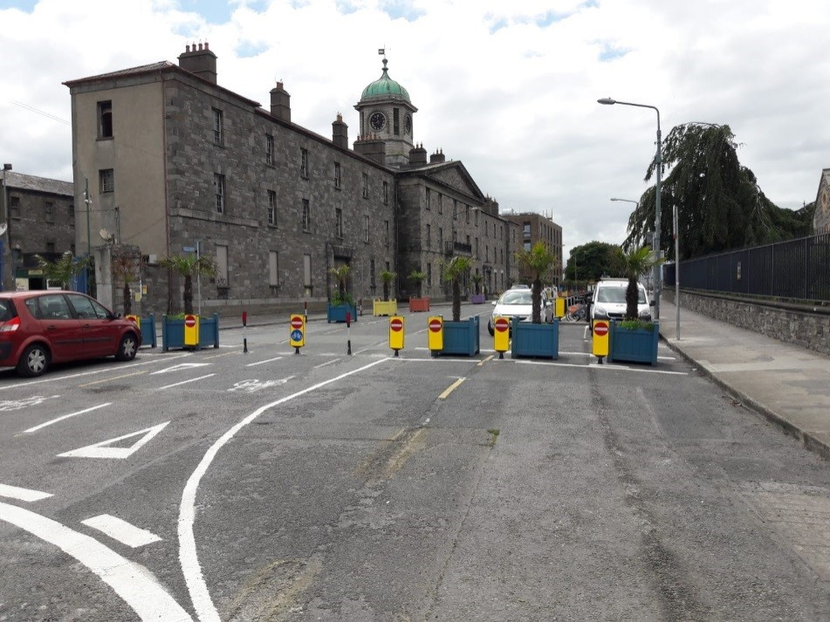

Figure 7: Road Closure to Motor Vehicles

### Access Restrictions and Left/Right Turning Bans

Turning Restrictions (Except Cyclists and Access) were introduced from North Circular Road onto Grangegorman Upper and Rathdown Road, and from North Brunswick Street onto Grangegorman Lower to minimise the amount of motorised traffic entering the wider area.

Motor vehicle access to any premises such as a house, business, service, school or college in the area is permitted, although some journeys are required to take a more circuitous route (via North Circular Road or North Brunswick Street) depending on which side of the bollards the premises is located.

### Pedestrianised Street (Except Access and Cyclists)

A Pedestrianised Street (Except Access and Cyclists) was installed on Grangegorman Lower to the south of the Road Closure to Motor Vehicles, extending southwards for a distance of 150 meters. A number of planter boxes and hatched markings were installed on the east side of Grangegorman Lower to further traffic calm the pedestrianised zone. In additional, clearway signs were installed to prevent parking to further reduce the volume of motorised vehicles in the pedestrian zone (Fig. 8).

Private motor vehicles are not permitted to travel on this section of road except for vehicles requiring access to a premises such as the TU Dublin Campus or Bring Centre.

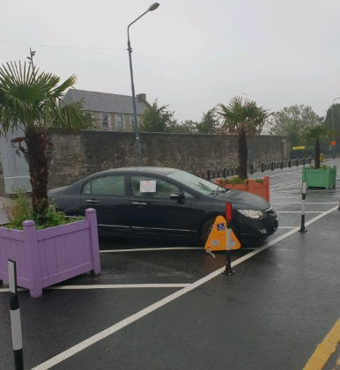

Figure 8: Car parked in an illegal manner is clamped by DCC’s Parking Enforcement Section

## Implementation and Duration of Trial

The trial commenced on the morning of 6th July 2020 with the introduction of filtered permeability measures on Grangegorman Lower (Fig. 9).

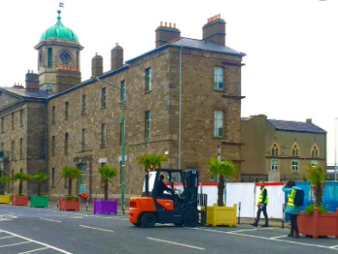

Figure 9: Implementation of trial by DCC Covid Mobility Team

The duration of the trial was initially for a four week period (6th July – 2nd Aug 2020). However, at subsequent Central Area Committee meetings, the elected members proposed and agreed that the trial should be extended firstly until 28th September 2020, and again until 31st January 2021 to facilitate feedback from the Councillors at the January 2021 Central Area Committee meeting.

This report is being presented to Councillors at this meeting and feedback is being sought from the Councillors.

#### BusConnects Modelling

The scheme as installed for over six months has now allowed traffic flows and routing to have settled in the area even during the various stages of Government restrictions with traffic volumes in the area continuing to be around 75-80% of pre Covid. The Bus Connects project will take account of Grangegorman being closed on a more permanent basis in their modelling work. The marked increase in walking and cycling in the area also means a reduction in car traffic in the overall area as people now are more comfortable in the safer environment created by this scheme.

# Data Collection and Analysis

## Motor Car Availability in Grangegorman

According to CSO Census Data (2016) (Fig. 10), 60% of households in the Grangegorman Area do not own a car at all (Fig. 11), despite observations and traffic data highlighting high volumes of motorised traffic travelling through this residential area.

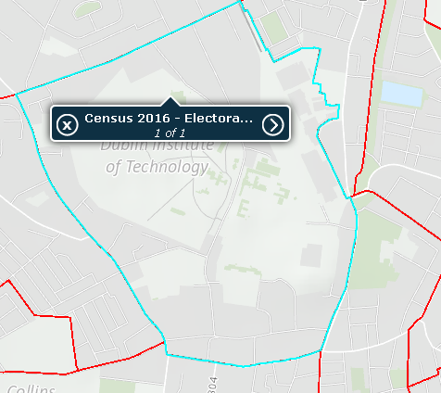

Grangegorman Lower / Location of Filter

NCR

Manor St

**TU Dublin / Grangegorman**

Figure 10: Census 2016 Data for Grangegorman taken from Electoral Division Arran Quay B

This is much higher than the national average (16%) and the Dublin City average (36%), which suggests that the people of Grangegorman are much more reliant on other modes of transport (e.g. walking, cycling and public transport) as a means to travel, compared to other areas in the city. However, with public transport capacity greatly reduced and while the need to socially distance remains in place, we need to enable the local community to make short trips to school, shops and work by cycle and on foot, and thus, leaving the reduced capacity on public transport for those that really need it.

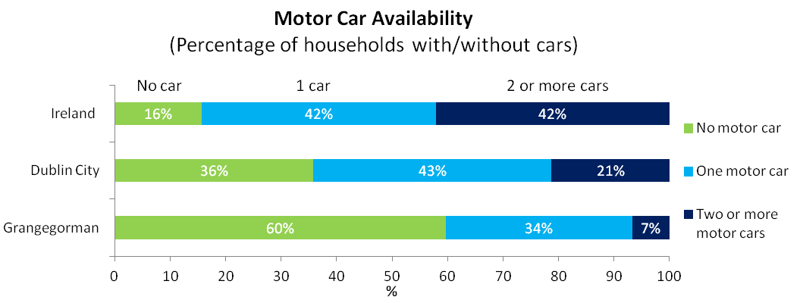

Figure 11: Motor Car Ownership in Grangegorman, Dublin City and Ireland

Furthermore, the latest CSO Transport Bulletin (7th Dec 2020) shows a continuing trend whereby vehicular traffic (e.g. cars) is recovering from a Covid-19 slump much faster than public transport. For instance, the number of journeys by bus and rail is 61% lower than pre-COVID-19 levels. Car usage, meanwhile, has consistently been at 70% of its usual level since June 2020 and is continuing to rise as lockdown restrictions begin to ease. This suggests that a proportion of the public may be avoiding public transport due to risks associated with Covid-19 and opting to drive instead. However, as 60% of households in the Grangegorman Area do not have access to a car, there is an increasing requirement to facilitate travel by alternative modes of transport such as walking and cycling.

Filtered permeability measures in Grangegorman can help local streets to work better for those people who do not have access to a car. While residents in Grangegorman can still do all their journeys by car if they want or need to, some trips will be slightly more circuitous. This, combined with quieter, safer-feeling streets, enables residents to switch to more healthy ways of getting around, particularly for short journeys.

## Commuting in Grangegorman

Walking is the most common mode of transport for commuting among Grangegorman residents. In April 2016, more than half of commuters (56%) from the Grangegorman Area either walked or cycled to Work, School or College (Fig. 12). This is much higher than the national average (18%) and the Dublin City average (38%). While only 16% of commuters living in Grangegorman travelled by car, more than 6 in 10 did so in Ireland. In Dublin City, almost 4 in 10 people used a car to commute.

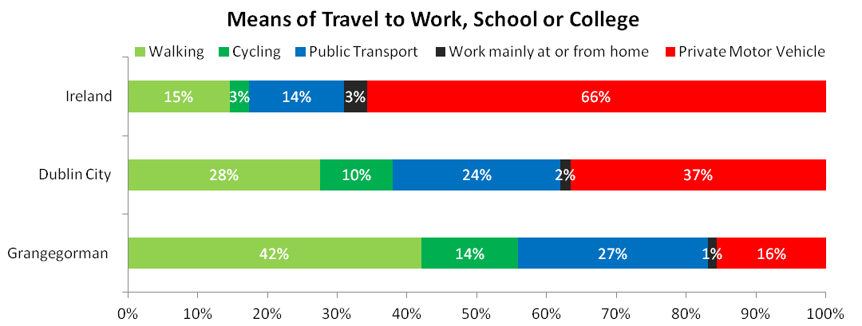

Figure 12: Means of Travel to Work, School or College in Grangegorman, Dublin City and Ireland

Dublin City Council recognises that capacity on public transport is restricted due to social distancing and that the easing of restrictions is increasing the demand to travel to work, shops, schools and other local amenities. Furthermore, a proportion of the public may choose to avoid public transport due to Covid-19 and opt to drive instead. Therefore, there is a likelihood that journeys by private car may start to significantly increase, leading to problems with road safety and pollution from vehicle emissions which will have a negative impact on the environment. The residential streets in the Grangegorman Area are vulnerable to through traffic bypassing the main road network which can affect both quality of life and public health for residents, and particularly for those who do not have access to a car and who will increasingly rely on walking and cycling as a means to travel.

Filtered permeability measures in Grangegorman can eliminate cut-through traffic and facilitate a safe walking and cycling route and a calmed neighbourhood.

## Traffic Surveys

### Mode Share

#### Pre-Implementation Mode Share Data

Vehicular movement data collected over a three day period from Fri 3rd – Sun 5th November 2017 provides a clear insight into the nature of traffic travelling within Grangegorman before implementation of the trial. During this period, a considerable volume of over 3,300 motor cars travelled through Grangegorman Lower, while 131 bicycles were recorded. This shows that the car was the dominant mode of transport travelling in the area, comprising a 96% share of transport compared to cycling (4%) (Fig. 14). However, according to CSO Census Data (2016), there is almost an equal share between both modes with 16% of commuters living in Grangegorman travelling by car, and 14% travelling by bicycle. This suggests that a significant proportion of these cars were non-local drivers using Grangegorman as a cut-through route (Fig. 13).

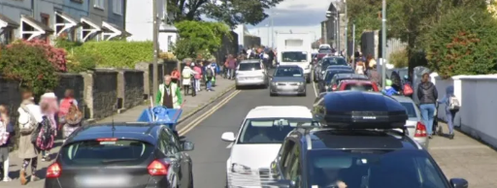

Figure 13: Before the trial - Grangegorman Lower is a car dominated street as school children attempt to walk and cycle to school

#### Monitoring Mode Share Data

Traffic monitoring took place during the trial over a three day period from Fri 4th – Sun 6th December 2020 to understand changes in traffic patterns. The results show that the volume of motor cars travelling on Grangegorman significantly dropped by 80% from 2017 levels of 3,300 to 600 cars (Fig. 14).

It should be noted that the pre-trial 2017 surveys were conducted pre-LUAS. It is clear that the LUAS has had a positive impact on commuting patterns in this area, with the volume of motorised traffic in the area reducing by around 20% after the LUAS opened.

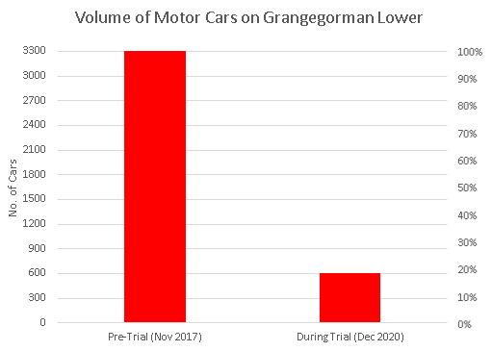

Figure 14: Volume of motor cars was approx. 3,300 cars before the trial and 600 cars during the trial.

Observational surveys during the trial indicate that these drivers are mostly accessing the Bring Centre, TU Dublin Campus, or their homes. This demonstrates that the trial has succeeded in eliminating cut-through traffic through the area. This aim is in line with Dublin City Council Development Plan 2016-2022 paragraph MT044 which refers to the implementation of traffic calming measures including the restriction of rat-runs in residential areas.

The raw survey data indicates that the trial has resulted in a much improved balance between motor cars (85%) and cyclists (15%) (Figs. 15, 16 & 17) and if the filtered permeability measures were retained in place, will likely play a critical role in achieving the ambitious future modal split targets for Grangegorman (Fig. 5), as agreed between DCC and GDA.

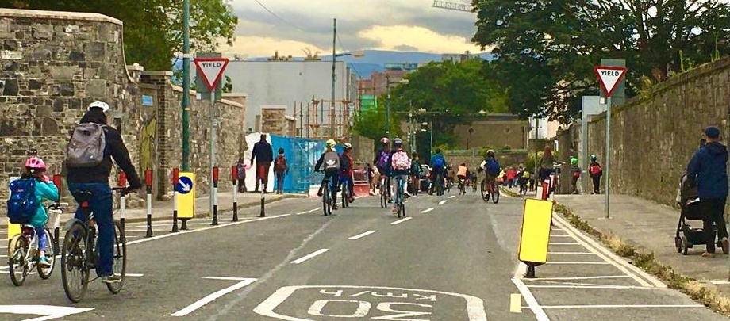

Figure 15: During the Trial - Grangegorman Lower is a walking and cycling friendly-street as children safely travel to school

|  |  |
| --- | --- |
| **Pre-Trial** | **During Trial** |
| Figure 16: Pre-Trial Car vs Two-Wheeler Mode Share | Figure 17: During-Trial Car vs Two-Wheeler Mode Share |

It is worth mentioning here that every motor car in the survey was recorded twice as they had to turn around at the filtered permeability measures and travel past the traffic survey sensor a second time, whereas cyclists could travel through the filter and may only have travelled past the sensor once during the survey period. Therefore, processing the raw data by dividing the number of cars by two (600 ÷ 2 = 300 cars in total) provides a more accurate representation of the actual modal split between cars (74%) and cyclists (26%) (Fig. 18). This indicates a much more evenly balanced split between the two modes.

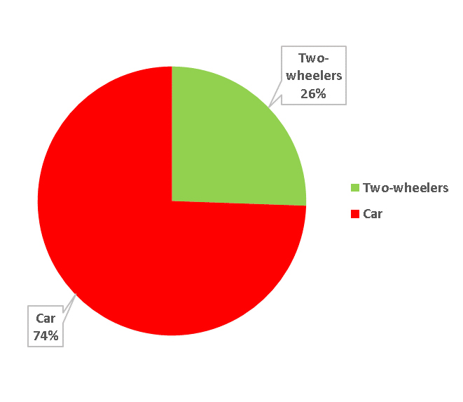

Figure 18: A more accurate representation of During-Trial Mode Share between Car and Two-Wheelers

### Vehicular Speeds

#### Pre-Implementation Speed Data

Vehicular speed data collected over a three day period from Fri 3rd – Sun 5th November 2017 provides an insight into the speed of road traffic travelling on Grangegorman Lower before implementation of the trial. Analysis of the survey results indicates that the 85th percentile speed was 60km/hr which is two times higher than the 30 km/hr speed limit on the road (Fig. 20). This suggests that a significant proportion of vehicles were driving at excessive speeds in serious violation of the posted speed limit.

Speed is the biggest contributing factor to road deaths in Ireland. According to the RSA, 29% of road deaths between 1996 and 2004 in Ireland were due to speeding. RSA statistics show that 9 in 10 pedestrians will die when hit by a vehicle travelling at 60 km/h per hour, whereas 10% will die when the vehicle is travelling at 30 km/h (Fig. 19). A table outlining traffic accidents in the Grangegorman Area from the RSA database for the period 2005 to 2016 is available in Appendix F.

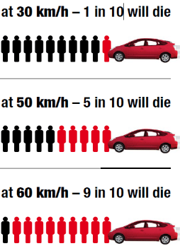

Figure 19: RSA collision statistics involving a pedestrian and a motor vehicle.

#### Monitoring Speed Data

Vehicular speed monitoring took place during the trial over a three day period from Fri 4th – Sun 6th December 2020 to understand changes in vehicle speeds. The results, presented in Figure 20, suggest that vehicular speeds on Grangegorman Lower has been significantly reduced by 38% from 2017 levels of 60km/h to 37 km/h during the trial.

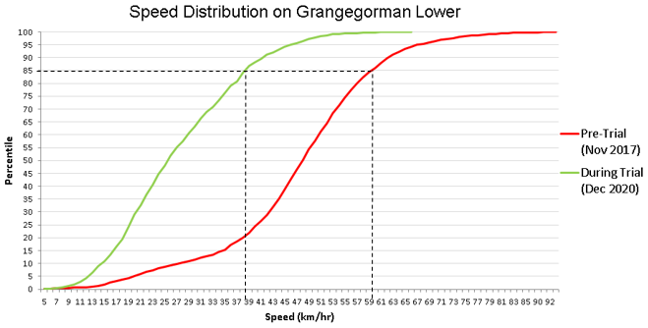

Figure 20: Pre-Trial vs During-Trial Speed Distributions on Grangegorman Lower

|  |  |
| --- | --- |
| **Pre-Trial Speed (km/h)** | **During Trial Speed (km/h)** |
| **60**  **2x faster than 30 km/h speed limit** | **37**  **38% reduction** |

These results indicate that the filtered permeability measures are significantly effective at reducing speeding in the area. When drivers use roads as a cut-through route, they are trying to get from A to B as quickly as possible. High volumes of non-local traffic can mean that lots of drivers who do not have an association with the area, are less likely to take care in how they drive. Filters give pedestrians and cyclists priority, whilst allowing access to drivers, altering the hierarchy of users and helping to reduce inconsiderate driving behaviours. These measures shorten the lengths of the drivable road, reducing the opportunity for drivers to build up speed, which can reduce the likelihood of a serious/fatal collision involving a speeding motor vehicle and a pedestrian.

## Observed Impacts of Trial

### Positive Impacts

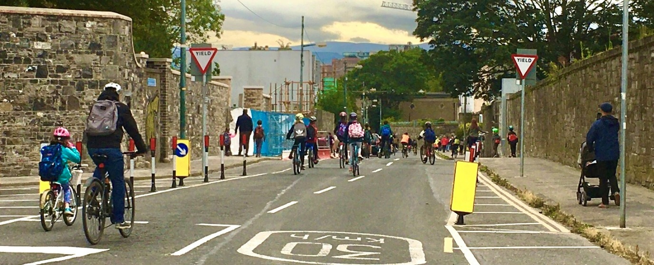

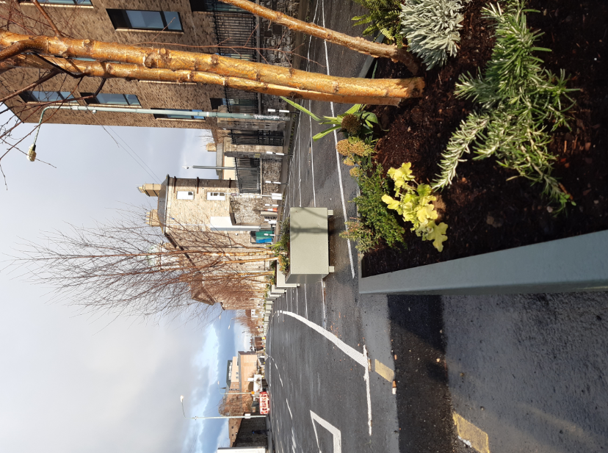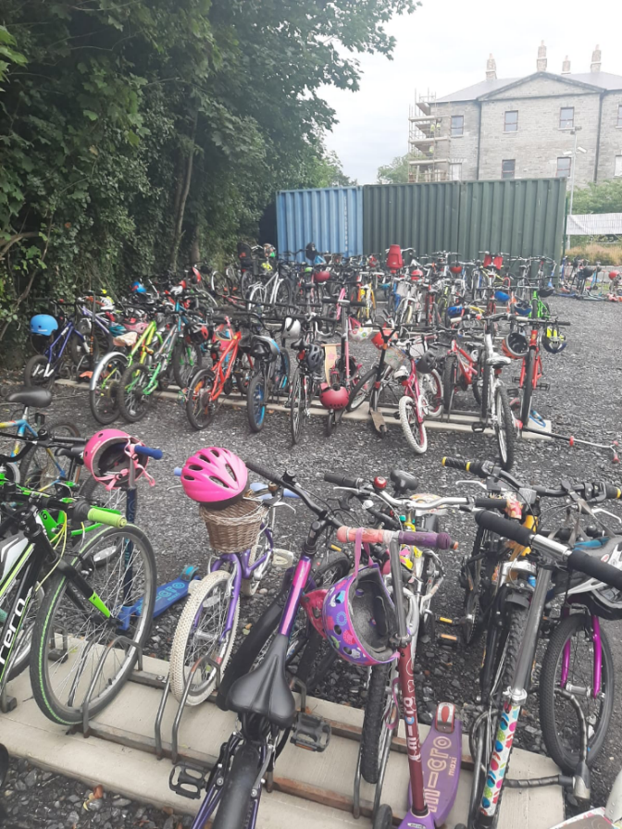

During the trial, some of the positive impacts of these measures include:

* Motorised cut-through traffic is eliminated on Grangegorman Lower so that drivers can no longer use this local route as a short-cut from North Circular Road to the Quays, and vice versa. This aim is in line with [Dublin City Council Development Plan 2016-2022](file:///\\dccdata\traffic\home\42689\Neighbourhood\Grangegorman\•%09https:\www.dublincity.ie\sites\default\files\content\Planning\DublinCityDevelopmentPlan\Written%20Statement%20Volume%201.pdf) paragraph MT044 which refers to the implementation of traffic calming measures including the restriction of rat-runs.
* Less motorised traffic has created a safer space for local residents and for thousands of pedestrians and cyclists arriving at TU Dublin, and travelling through the area.
* Improved modal share has benefited public health by encouraging walking and cycling, and promoting social interaction and inclusion.
* Reduction in motorised traffic likely improved local air quality and reduce noise pollution.
* Reduced car speeds has created a safer and more liveable area for residents of Grangegorman Upper & Lower, Rathdown Road, Marne Villas, Fitzwilliam Place North, Stanhope Street and Kirwan Street.
* Pedestrian safety is improved for the large numbers of LUAS passengers walking east to west (and vice-versa) across Grangegorman Lower.
* Local vehicular access to Grangegorman has been retained and vehicular access points to TU Dublin Campus are unaffected.
* Access through the bollards is maintained for emergency vehicles.

### Negative Impacts

During the trial, some of the negative impacts of these measures included:

* Drivers who used to travel down Grangegorman Lower to access to Quays from North Circular Road (and vice-versa) are being inconvenienced as they have to take a longer more circuitous route on the more appropriate arterial roads which are designed for higher traffic flows.
* While the majority of residents support this scheme, some local residents who travel by private car are required to take a more circuitous route. For example, residents of Rathdown Road driving to Kirwan Street will be required to access Kirwan Street via North Brunswick Street.

# Consultation

## Pre-Implementation

The Covid Mobility team acknowledges that there was limited opportunity to consult to the same levels as would have been the norm pre-Covid-19. The trial was implemented as a Covid-19 emergency traffic measure in accordance with the policies set out in the DCC/NTA ‘Enabling the City to Return to Work: Interim Mobility Intervention Programme for Dublin City’, published in May 2020, which was approved by the City Council at its June 2020 meeting. As this was an emergency measure, it was not considered feasible to attempt to conduct pre-Covid-19 levels of consultation.

Nevertheless, significant effort was made to ensure that the Grangegorman Filtered Permeability Trial was communicated as broadly as possible. The concept for filtered permeability measures at Grangegorman was initially discussed with Councillors at the Central Area Committee Meeting in May and a presentation was given to Councillors at the June Area Committee meeting. The proposed measures were also highlighted via the Covid Mobility update issued by the Chief Executive on May 24th and again on July 2nd.

Consultation with local residents and stakeholders was initiated with notification leaflets informing them of the upcoming trial due for commencement and the temporary changes to traffic movements on Grangegorman. This information leaflet was delivered between Thursday 2nd July and Friday 3rd July to all households of Grangegorman Upper & Lower, Rathdown Road, Marne Villas, Fitzwilliam Place North, Stanhope Street and Kirwan Street. Key stakeholders groups in the area such as schools and the Bring Centre were also contacted via phone and email (with the information letter attached) informing them of the trial.

In the information leaflet, residents and stakeholders were invited to provide feedback on the trial to our dedicated email address: [covidmobility@dublincity.ie](mailto:covidmobility@dublincity.ie). A copy of the letter is shown in Appendix D and the letter drop catchment areas are shown in the ‘boundary line of trial’ in Fig. 1 above.

Information on the trial was publicised via the Dublin City Council Twitter and Facebook accounts. Copies of these posts are shown in Appendix E.

## Post-Implementation

Dublin City Council have carried out extensive consultation since the commencement of the trial. Public Consultation has involved elements such as:

1. Over 11,000 Leaflets distributed to local residents & stakeholders
2. Consultation with local schools, the University, health care centres and other relevant stakeholders.
3. Covid Mobility updates issued by the Chief Executive at Area Committee Meetings.
4. Presentations at Central Area Committee Meetings.
5. Updates on the trial publicised via the Dublin City Council Twitter and Facebook accounts.
6. Information published on the DCC Consultation Hub.
7. Installation of Advanced Traffic Warning signs including two Variable Message Signs (VMS) installed 1 week in advance of the trial and for the duration of the trial.

At the July Area Committee meeting, an update on the trial was highlighted via the Covid Mobility update issued by the Chief Executive. At this meeting, the elected members proposed and agreed that the trial should be extended until 28th September 2020. The extension was to facilitate feedback from the Councillors at the September 2020 Area Committee meeting on whether the trial should be removed, amended or extended for a specific period.

Following this, a further consultation with local residents and stakeholders was carried out with notification leaflets informing them of the extension to the trial end-date. This information leaflet was delivered between Thurs 30th July and Fri 31st July to all households of Grangegorman Upper & Lower, Rathdown Road, Marne Villas, Fitzwilliam Place North, Stanhope Street and Kirwan Street.

In the information leaflet, residents were again invited to provide feedback on the trial to our dedicated email address: [covidmobility@dublincity.ie](mailto:covidmobility@dublincity.ie). A copy of the letter is shown in Appendix D and the letter drop catchment areas are shown in Fig. 1 above.

Updates on the trial was also publicised via the Dublin City Council Twitter and Facebook account. Copies of these posts are shown in Appendix E.

At the September 2020 Central Area Committee meeting, a comprehensive report on the trial was circulated via the central area office to all councillors. In the report, feedback received from stakeholders during the period 3rd July to 27th August was summarised and issues raised were responded to. An update on the trial was also highlighted via the Covid Mobility update issued by the Chief Executive. At this meeting, the elected members proposed and agreed that the trial should be extended until 31st January 2021. This extension was to facilitate feedback from the Councillors at the January 2021 Area Committee meeting.

Following this, a further consultation with stakeholders was carried out with information leaflets informing them of the extension to the trial end-date. On Thurs 15th October, this information leaflet was delivered to local residents and businesses in the areas of Grangegorman Upper & Lower, Rathdown Road, Marne Villas, Fitzwilliam Place North, Stanhope Street and Kirwan Street. This information leaflet was also circulated to all central area councillors and published on the DCC Consultation Hub.

This information leaflet was subsequently delivered between Mon 9th – Fri 13th November to approx. 10,700 households in areas of Grangegorman, Stoneybatter, Arbour Hill, Phibsborough, Broadstone and Cabra East. A copy of the letter is shown in Appendix D and the letter drop catchment areas are shaded in green in Fig. 21 below.

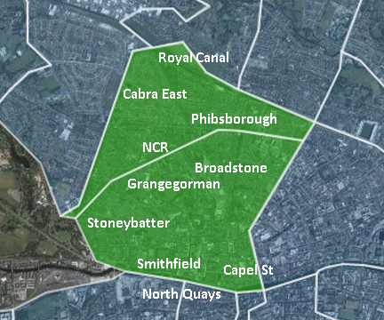

Figure 21: November Letter Drop Catchment Areas (shaded in Green)

In the information leaflet, stakeholders were invited to provide feedback on the trial to the dedicated email address: covidmobility@dublincity.ie, or alternatively via post to our office address provided on the leaflet. Deadline for receipt of submissions was 1st December 2020 as stated on the leaflet.

Updates on the trial was also publicised via the Dublin City Council Twitter and Facebook account. Copies of these posts are shown in Appendix E.

# Consultation Feedback

## NTA / Busconnects

Some concern had been expressed that the NTA Bus Connects project does not take account of the new status of this Grangegorman link and that the modelling work to date does not reflect the changed arrangements in the area.

John Fleming, Project Manager BusConnects made the following observation regarding this:

1. The BusConnects Infrastructure Team, and the Blanchardstown to City Centre CBC Scheme and the Ballymun to City Centre Scheme designers are aware of the trial and the NTA are supportive of the objectives of the scheme. Because of the current temporary nature of the scheme it has not been factored into the initial work of the design teams but if the trial is continued or made permanent then this would be factored into the work of the design team.
2. The planning work for both CBC Schemes is being progressed taking local traffic impacts into account in the assessment and this would be updated as required to take account of the status of Grangegorman.

## Public Feedback

### Overview of Feedback

974 emails were received from 3rd July 2020 to 1st December 2020 via our dedicated [covidmobility@dublincity.ie](mailto:covidmobility@dublincity.ie) email address on the impact of this trial of which: 586 (60 per cent) supported the trial, 378 (39 per cent) did not support the trial, and 10 (1 per cent) had no opinion (Fig. 22). 122 submissions were actioned separately.

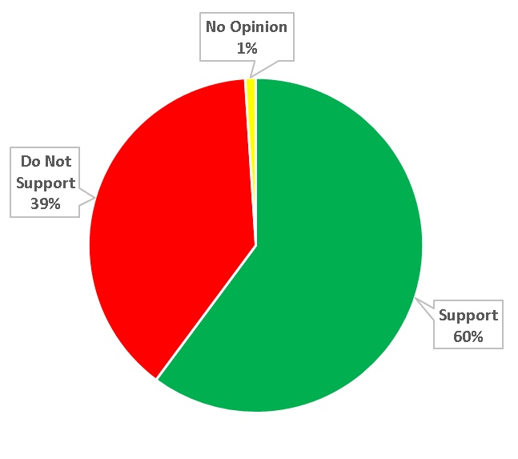

Figure 22: Pie chart showing 60% supported the trial, 39% did not support the trial, and 1% had no opinion.

Information on the trial which was publicised via the Dublin City Council’s social media Twitter and Facebook accounts has been seen by a combined total of over 285,000 people. Over 17,000 people engaged (e.g. liked, commented, shared) with our posts on Twitter and Facebook.

### Support

The top three most popular supporting comments were as follows:

1. Road safety has significantly improved as a result of less motor traffic on the roads e.g. for walking and cycling, especially for children and other vulnerable road users.
2. Trial encourages sustainable transport modes such as walking and cycling.
3. Less traffic on the roads has improved the environment e.g. in terms of air quality and noise pollution.

The responses to these supporting comments are documented below.

1. Road safety has significantly improved as a result of less motor traffic on the roads e.g. for walking and cycling, especially for children and other vulnerable road users.

Response: Improving road safety is one of the main aims of the trial to better facilitate an increased level of walking and cycling in the city. Before and after traffic surveys show that the volume of motor cars travelling on Grangegorman significantly dropped by 80% during the trial (from 2017 levels). This creates a safer environment for walking and cycling, and is likely to reduce people’s exposure to dangerous pollutants, especially to vulnerable road users such as school children.

Pre-trial speed surveys carried out on Grangegorman Lower in November 2017 indicates that the 85th percentile speed was 60km/hr which is two times higher than the 30 km/hr speed limit on the road. Speed is the biggest contributing factor to road deaths in Ireland. Filtered permeability measures shorten the lengths of the drivable road, reducing the opportunity for drivers to build up speed. Speed surveys carried out in December 2020 show a reduction from 60 km/h (in 2017) to 37 km/hr during the trial. This can significantly reduce the likelihood of a serious/fatal collision involving a speeding motor vehicle and a pedestrian.

1. Trial encourages sustainable transport modes such as walking and cycling.

Response: One of the main positives of the trial is facilitate and encourage sustainable modes of transport in the city. This aim is in line with Dublin City Council Development Plan 2016-2022. Walking is the most common mode of transport among Grangegorman residents, with more than half of commuters (56%) either walking or cycling. This is much higher than the Dublin City average (38%). While only 16% of commuters living in Grangegorman travelled by car, almost 4 in 10 people did so in Dublin City. This suggests that the people of Grangegorman are much more reliant on other modes of transport (i.e. walking, cycling and public transport) as a means to travel compared to other areas in the city, especially at a time of reduced public transport capacity. However, pre-trial traffic surveys carried out in 2017 show a high volume of motor traffic on Grangegorman Lower, with motor cars dominating the modal share in this area. Traffic surveys carried out during the trial indicate a much improved balance between motor cars and cyclists, which can help us achieve the ambitious future modal split targets for Grangegorman, as agreed between Dublin City Council and Grangegorman Development Agency. These measures are proving vital for making walking and cycling safe and comfortable options for local residents and for the thousands of students travelling to the TU Dublin campus.

1. Less traffic on the roads has improved the environment e.g. in terms of air quality and noise pollution.

Response: Improving the environment is another significant positive of the trial to better facilitate an increased level of walking and cycling in the city. An improved environment can have benefits for public health by encouraging walking and cycling, and promoting social distancing, interaction and inclusion. In the case of air pollution, less motorised traffic on the roads is likely to reduce people’s exposure to dangerous pollutants, especially to vulnerable road users such

### Concerns

The top four most popular non-supporting comments/concerns were as follows:

1. Congestion will increase on adjacent roads and junctions e.g. Hanlon’s corner, Doyle’s corner and North Circular Road.
2. Driving a more circuitous route has added significant time to my journey.
3. It is now too difficult to access a premises in Grangegorman by motor vehicle such as the Bring Recycling Centre.
4. The area is poorly lit at night time leading to people feeling unsafe.

The responses to these non-supporting comments/concerns are documented below.

1. Concerns that congestion will increase on adjacent roads and junctions e.g. Hanlon’s corner, Doyle’s corner and North Circular Road.

Response: There is a common misconception that the trial is causing delays to the above junctions. Modifications were made to these signalised junctions to allow for more pedestrian green time, to alleviate the risk of bunching of pedestrians who are attempting to socially distance while waiting to cross the road. This is impacting on congestion and delays at these locations. Further to this, the ITS section have informed that traffic volumes increased to around 80% of pre Covid volumes as Covid-19 travel restrictions were lifted, with the Grangegorman Trial unlikely to have much impact on junction queueing times. If the trial was made permanent further research could be done on this point.

Research shows that when through traffic is completely removed from a residential street, the experience in general is that main arterial roads have far more capacity to cope than the residential side streets – so increases in motor vehicle volumes seen on main arterial roads are low in percentage terms, and after an initial period of bedding in, traffic settles to broadly where it was before. 15% or so of traffic over the area is likely to “evaporate” in such schemes – moving out of the area entirely or switching mode e.g. to walking, cycling or public transport. In other words, congestion levels do not go up with these types of schemes.

1. Concerns that driving a more circuitous route has added significant time to their journey.

Response: One of the main positives of the trial is to eliminate cut-through traffic on Grangegorman Lower. This aim is in line with Dublin City Council Development Plan 2016-2022 paragraph MT044 which refers to the implementation of traffic calming measures including the restriction of rat-runs in residential areas. Accordingly, drivers who previously used Grangegorman as a cut-through route from North Circular Road to the Quays (and vice-versa) will be inconvenienced as they will have to drive a more circuitous route on the arterial roads which are designated to accommodate larger volumes of traffic.

Due to the nature of the filtered permeability measures, one of the anticipated negative impacts of this trial is that some drivers accessing a premises in the Grangegorman Area may also have to take a more circuitous route depending on which side of the bollards the premises is located. There is sometimes concern that filtered permeability measures will increase congestion and associated pollution on the main arterial roads. The evidence shows this not to be the case. It can take months for traffic patterns to settle, but medium-term “traffic evaporation” is well-evidenced. Research suggests that around 15% of displaced traffic disappears from the area entirely as drivers adjust routes and behaviour – avoiding the area, changing to sustainable transport modes or even cancelling journeys.

1. It is difficult to access the Bring Centre in Grangegorman by motor vehicle.

Response: We agree that difficulty was experienced in accessing the Bring Centre. To address this, management of the Bring Centre were consulted during the design and operational stages of the trial. The original trial design provided 3/4 Pay & Display (Non-residential) car parking spaces to the North and South of the bollards/planters. If the trial is extended a detailed design will be finalised that will double the amount of parking spaces to 7/8 spaces. The maximum allowed parking time at this location has been reduced from 3 hours to 1 hour to ensure the availability of short stay car parking for customers of the Bring Centre.

1. The Area is poorly lit at light time, leading to people feeling unsafe.

There has been concern that public lighting has not been adequate and therefore people can feel unsafe at this location. With this in mind, DCC have carried out a lighting assessment and found that the light levels are very good meeting class P3 of BS5489 for Road Lighting.

We believe that when Covid-19 restrictions begin to be eased and the university returns and other local activities and sports begin to return, the increased footfall will greatly improve the perception of safety in the area. Further to this DCC will be upgrading all lights to LED in the city over the next number of years and Grangegorman Lower will be considered for upgrade in the early phases of this project which is expected to commence in Autumn 2021.

Monck Place, AVondale Road, Great western square anD surrounding streets.

A submission with 122 signatures was received from the residents of Monck Place, Avondale Road, Great Western Square and surrounding streets. Following consultation with the residents of this area, Dublin City Council continue to develop a detailed plan to alleviate some perceived traffic issues.

A number of workshops have been held with residents and Councillors on the matter. A brief update was given at the November Central Area Committee meeting, followed by a detailed update at the December Central Area Committee. A number of meetings have since been held with residents and we continue to work on our proposal as agreed with residents at these meetings.

It is anticipated that following further consultation with residents in January 2021 we will provide an update to Councillors at the February Central Area Committee meeting.

## Schools Consultation

|  |  |
| --- | --- |
| \\dccdata\Traffic\Shared\General\Covid 19 Mobility Interventions Program\Business & Communications\Communications\Schools Mobility\School Feedback on Grangegorman Trial\Student survey Grangegorman trial\Student artwork\20201124_145223.jpg | \\dccdata\Traffic\Shared\General\Covid 19 Mobility Interventions Program\Business & Communications\Communications\Schools Mobility\School Feedback on Grangegorman Trial\Student survey Grangegorman trial\Student artwork\20201124_150025_resized.jpg |
| \\dccdata\Traffic\Shared\General\Covid 19 Mobility Interventions Program\Business & Communications\Communications\Schools Mobility\School Feedback on Grangegorman Trial\Student survey Grangegorman trial\Student artwork\20201124_150148_resized.jpg |  |
|  |  |

Figure 23: Selected artwork from school children submitted as part of the consultation process with schools.

The principal of Stanhope Street primary school stated in their submission that they were opposed to the scheme while the principal of Dublin 7 Educate together stated that they were in favour of the scheme.

Further to this, Dublin City Council requested three schools (St Paul's CBS, Dublin 7 Educate Together National School, and Stanhope Street Primary School) in the area to ask their pupils to complete a questionnaire survey on the trial. Over 500 school pupils returned completed questionnaires for DCC to analyse. In the questionnaire, Pupils were asked the following three questions:

1. How do you usually travel to school?
2. Have you used the car-free street?
3. How does it affect your journey to school?

The survey results from all pupils show that the most popular means of travel to the schools is by active transport modes. Almost 8 in 10 (78%) pupils travel to school by either cycling (32%), walking (30%) or scooting (15%). Less than 1 in 5 pupils travel by car (18%), which is much lower than the Dublin City average (36%) (CSO Census 2016). Only 1 in 20 (5%) travel by public transport (Fig. 24).

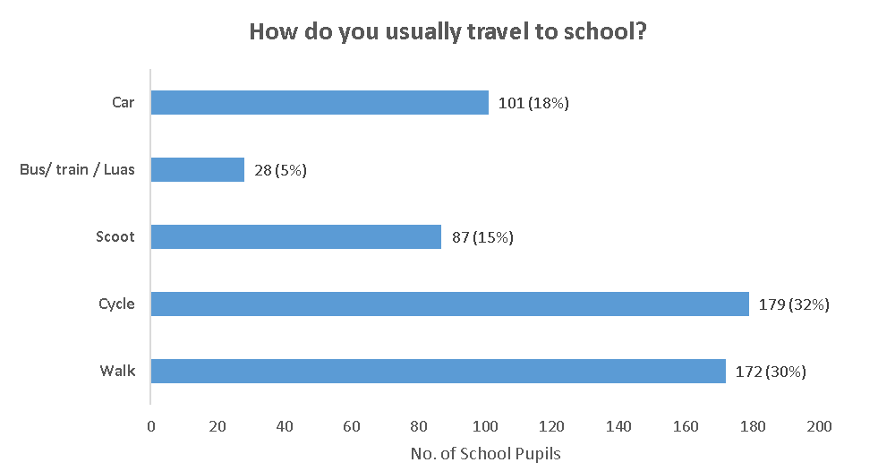

Figure 24: Bar chart showing school pupils primary means of travelling to the schools

Over three quarters (77%) of all pupils stated that they have travelled on Grangegorman Lower with the filtered permeability measures in place (Fig. 25).

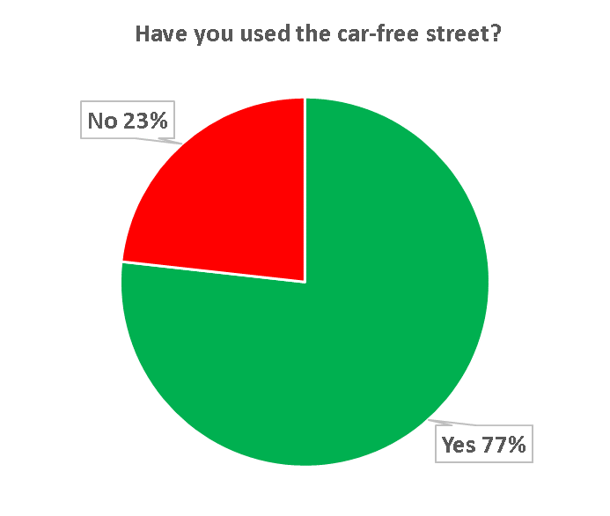

Figure 25: Pie chart showing 77% of all pupils travelled on Grangegorman Lower with the trial in place

Over half (53%) of all pupils think that the road is better to travel on for reasons such as improved safety and an enhanced environment. 36% stated that the measures had no effect on their journey, while 1 in 9 (11%) thought that the measures made their journey worse for reasons such as increased travel time by car (Fig. 26).

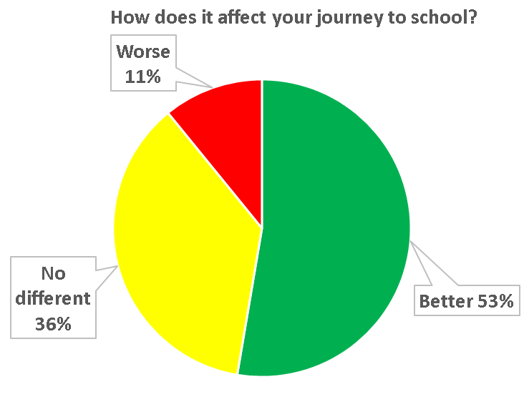

Figure 26: Pie chart showing 53% of all pupils think that the road is better with the trial in place, 39% think that it has no effect and 11% think that it is worse

School children who provided comments on the trial is available in Appendix G.

## Summary of Feedback

The general opinion following the analysis of feedback shows that there is strong support for the Grangegorman Filtered Permeability Trial, with many respondents stating that they feel the area has improved for the following reasons:

* Road safety has significantly improved, especially for school children.
* Trial encourages sustainable transport modes such as walking and cycling.
* Less traffic has improved the environment in terms of air quality and noise pollution.

While there was a number of issues identified, these have been taken into consideration, and are being addressed as part of the trial. Further reviews can be considered dependent on the feedback from the elected members.

Feedback received through the Covid Mobility Programme’s dedicated email ([covidmobility@dublincity.ie](mailto:covidmobility@dublincity.ie)) showed a level of 60% approval for the scheme (Fig. 27).



Figure 27: Pie chart showing 60% supported the trial, 39% did not support the trial, and 1% had no opinion.

The Team has reviewed all the submissions received via this email in addition to correspondence received from various stakeholders which have been broadly positive and supportive of the trial. The primary concerns have been acknowledged in relation to displaced congestion and parking near the bring centre.

The Team has now provided responses to these primary concerns, in addition to amendments to the design; in particular increasing the parking provision near the Bring Centre, and optimising signal times on all nearby junctions including Hanlon’s Corner and Doyle’s Corner to reduce waiting times for all road users, have all been taken into account and are being addressed as part of the trial.

# Conclusion and recommendation

Filtered permeability measures are not about rewarding one group of people while punishing another, but about making long-term decisions about how people travel, by delivering safer environments for people to travel by a range of sustainable modes. Pre-implementation traffic surveys show that a high volume of motor cars travel through this residential area despite the fact that 60% of households in the Grangegorman Area do not have access to a car and more than half of commuters (56%) either walk or cycle.

The proposal of the Grangegorman Filtered Permeability Trial is a means to tackle the issues that have been raised with Dublin County Council by various stakeholders in the community as outlined in this report. The measures included as part of the trial have been implemented to facilitate and support the implementation of the Dublin City Covid Mobility Programme.

**Recommendation**

Having gone through the process, our recommendation is to make the filtered permeability permanent as this type of scheme is fully in line with DCC policies and it has been shown to be beneficial and to achieve a marked improvement in safety and ability for people of all ages to walk and cycle in this area.

If the elected members are concerned about the impacts of the scheme once the Covid-19 restrictions have been finally lifted and the full numbers of students and staff are now in place using the campus, we are agreeable to having a 12-18 month review period where a detailed report can be brought back to the members on how the scheme has impacted as Covid-19 restrictions have been lifted.

It will give us an opportunity to facilitate design workshops with key stakeholders to further develop the design ensuring that it overcomes the concerns raised during the consultation process. During the course of the project, relevant information and project updates can be made available to Councillors at Area Committee meetings or as requested. The design would likely involve temporary public realm improvements such as reinstatements and modifications to the footpaths, carriageway and other related works in the context of the planned future public realm improvements being planned by TU Dublin at this location shown indicatively below (Fig. 28).

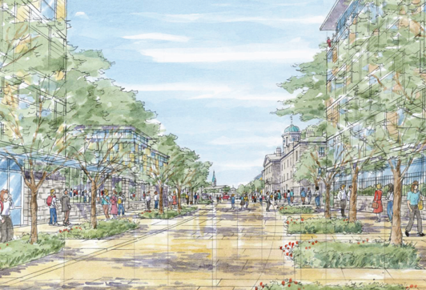

Figure 28: Artists Impression of Grangegorman Lower with low traffic and priority given to pedestrians and cyclists

# Appendix A

The Chief Executive Owen Keegan Dublin City Council Wood Quay, Dublin 8 D08 RF3F

Re: Temporary bollard trial for walking and cycling

Dear Mr Keegan,

We, residents of Rathdown Road, Grangegorman Upper, Charleville Road, Cherrymount Park, Rosemount Road, Grangegorman Lower, Kirwan Street and Kirwan Street Cottages, are writing to request a trial of bollards across Grangegorman Lower. The purpose of this request is to enable greater volumes of walking and cycling on Grangegorman by restricting traffic to local-only. We are encouraged by document produced by Dublin City Council last week regarding emergency COVID-19 measures, and we particularly welcome the establishment of a working-group between DCC and the NTA. As the two largest stakeholders in Dublin’s transport governance environment, it makes total sense for you to work together to meet the challenges presented by COVID-19.

**The Proposal** The nature of Grangegorman Lower, Grangegorman Upper and Rathdown Road’s future role in the mobility networks of the Dublin 7 area has already been a hot topic in recent months, due to the changes proposed for the area by the BusConnects project. A public meeting held in Phibsborough in relation to BusConnects late last year, attended by 40 people, agreed near-unanimously to propose an idea for a plaza at the clock Tower at Grangegorman.

This proposal in this letter is functionally much the same as that one, which we have included a picture of on the following page.

**The request is to place a series of bollards across Grangegorman Lower - at a location to be determined between Marne Villas to the north and Kirwan Street to the south - on a trial basis.**

The impact on motor traffic would be this: **through-traffic would no longer be able to use Grangegorman as a short-cut f**rom North Circular Road to the Quays, and vice versa. **Local car access would be retained;** though depending on which side of the bollards one was located, some car journeys would take a more circuitous route. **Pedestrians and cyclists would be able to continue** through unrestricted. Vehicular access points to TUD Campus would be unaffected and access through the bollards could potentially be made for emergency vehicles.

**The Reasons Why**

1. **Footpath widths & social distancing.** The TUD campus has become an increasingly popular amenity since the crisis began and it is quite difficult at present to practice social distancing on the footpaths approaching the entrance, particularly on the stretch from Kirwan Street. It is not uncommon to see people walking on the road, but this is problematic given the speeds cars currently travel on the street. As traffic increases due to the issues with public transport, the guidelines will become difficult to adhere to.

2. **Providing a strategic north-south cycling ‘quietway’**, and an alternative to mixing with heavy traffic and buses in Stoneybatter and Phibsborough. The streets of Prussia Street, Manor Street and Stoneybatter are treated as an arterial route and such endure

significant traffic. Phibsborough is similar. The cycling facilities that exist are very limited and are usually blocked by illegal parking. If traffic on Grangegorman is reduced to local-only by bollards, then it will become an important artery for cycling, in a way that the Prussia Street / Manor Street route can never be due to the bus and car access requirements.

3. The TUD Grangegorman Campus is split in two by Grangegorman Lower, which is likely **to become a major thoroughfare** when the BusConnects proposals are implemented. Blocking through traffic could present the opportunity in the longer-term of providing a pedestrian plaza at the Clocktower. There will be significant foot traffic on the recently opened pedestrian route from Constitution Hill to Grangegorman, which will have to cross Grangegorman Lower to access the western portion of the Campus.

4. Construction of the new and expanded Educate Together School is about to commence at Grangegorman Upper. It would be much **safer for children** attending the school if through traffic was eliminated.

5. This proposal is in accordance with **DCC Development Objective paragraph MTO44** which states: “The implementation of traffic calming measures including rat-runs in appropriate in areas in accordance with best practice and following the advice contained in the Design Manual for Urban Roads and Streets.”.

**The Bollard Trial** Ideally this arrangement would be trialled for the summer months while traffic volumes are still low to allow citizens to give feedback. If it is well received, then it could potentially be extended into the beginning of the school term, and new university semester.

We note that DCC Beta is currently planning a School Streets programme. While this is not a school streets proposal, it could have similar effects. Grangegorman Lower is used to access Stanhope Street School, D7 Educate Together, and St Paul’s on Brunswick Street. Though most parents walk or cycle with their children, a limited number drive, and the narrow streets become quickly congested and chaotic. Those that walk and cycle do so on the pavements, as it is unsafe to use the road.

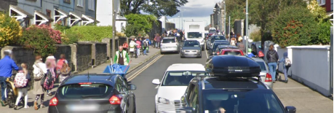

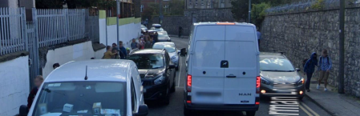

The above photos are below are taken from the Google Streetview of Grangegorman Lower. This would be a very problematic situation in ordinary times; and it will need to be avoided under the shadow of COVID-19.

We feel this proposal could deliver a significant shift in modal share towards active travel in the area and improve safety and quality of life for residents in the wider area. Many more people are cycling now but without dedicated, safe, pleasant spaces to do so, our streets will quickly become too unsafe to continue doing so. This trial could help solidify these positive new habits and help reduce traffic volumes. There will never be a better time to initiate a trial for this proposal so we hope you will give it serious consideration. TUD Grangegorman are supportive of proceeding with a trial and we have included Chief Planner in this correspondence.

# Appendix B

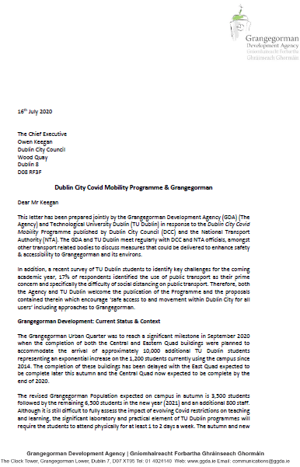

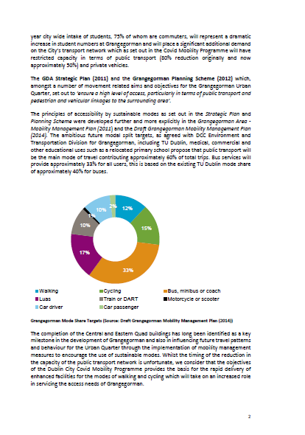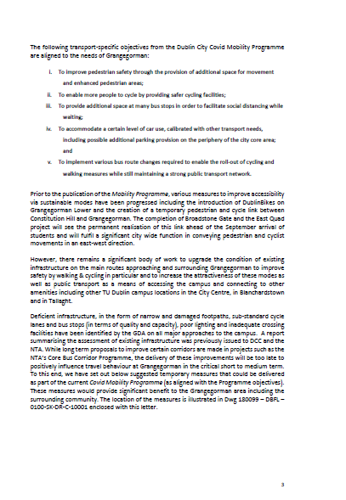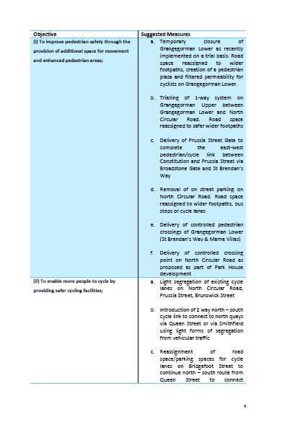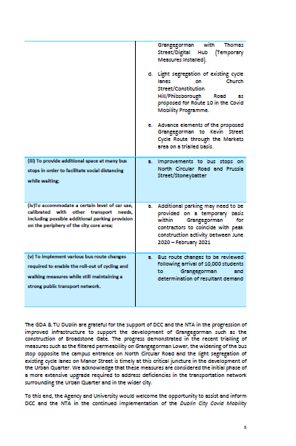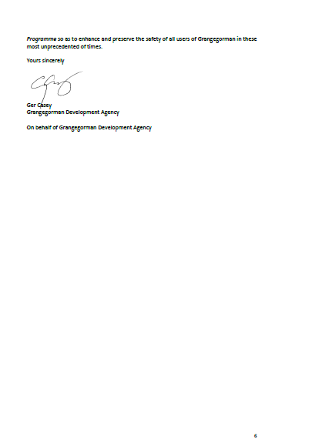

The above photos are below are taken from the Google Streetview of Grangegorman Lower. This would be a very problematic situation in ordinary times; and it will need to be avoided under the shadow of COVID-19.

We feel this proposal could deliver a significant shift in modal share towards active travel in the area and improve safety and quality of life for residents in the wider area. Many more people are cycling now but without dedicated, safe, pleasant spaces to do so, our streets will quickly become too unsafe to continue doing so. This trial could help solidify these positive new habits and help reduce traffic volumes. There will never be a better time to initiate a trial for this proposal so we hope you will give it serious consideration. TUD Grangegorman are supportive of proceeding with a trial and we have included Chief Planner in this correspondence.

# Appendix C

## Alternative Options which were deemed not appropriate

### Option 1

Install filtered permeability measures at a different location on Grangegorman Lower.

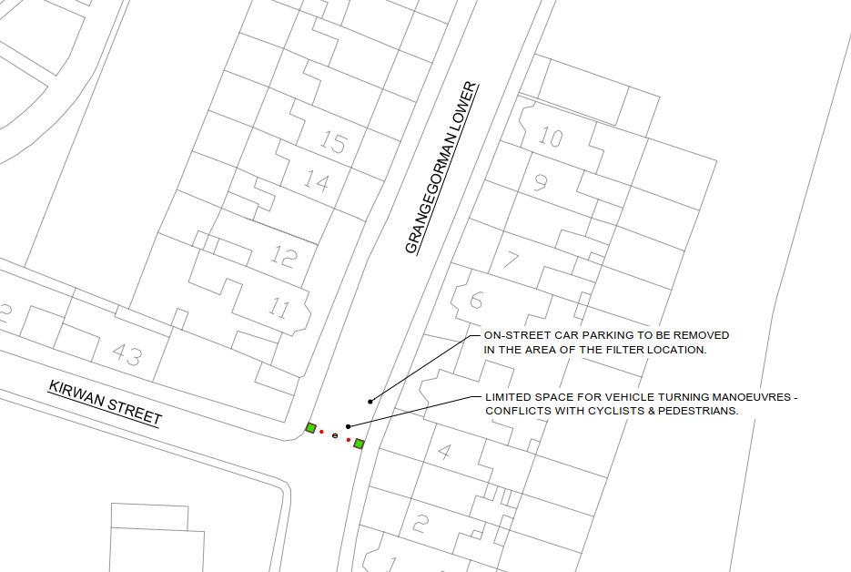

This option involves installing filtered permeability measures on Grangegorman Lower near the Grangegorman Lower/Kirwan Street junction. However, the narrow cross section of road (approx. 7m) at this alternative filter location would lead to more difficult manoeuvres for any motorists who arrive at the filters and need to turn around. This would lead to an increase in the number of potential conflicts between turning vehicles, cyclists and pedestrians, due to the narrower space available and the time required for manoeuvres. Access to TU Dublin Campus and Bring Centre would be more difficult, with motor vehicles having to access the these premises via North Circular Road. Therefore, this option was not further considered as a viable alternative.

### Option 2

Install fully segregated cycle lanes on Grangegorman Lower.

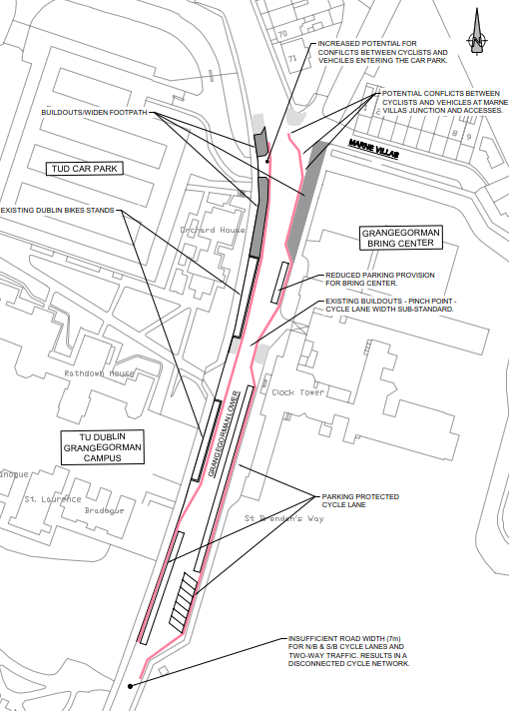

This option involves installing fully segregated cycle lanes for a section of Grangegorman Lower. With segregated cycle lanes and two-way traffic flow, there is a high number of potential conflicts between motorists, cyclists and pedestrians crossing each other at certain sections of the roadway. Therefore, this option would not be considered suitable to facilitate the safe movement of pedestrians and cyclists, particularly for vulnerable pedestrians travelling east to west (and vice-versa) on Grangegorman Lower.

High traffic volumes would likely remain on Grangegorman Lower, as it would still be used as a cut-through route. Therefore, segregated cycle lanes would not be effective at achieving one of the main positives of the trial i.e. to eliminate cut-through traffic. Given this high-traffic scenario, pedestrian facilities would need to be installed to accommodate the large pedestrian numbers alighting the LUAS. However, this would not alleviate the risk of bunching of pedestrians who are waiting to cross the road.

The existing Dublin Bikes Station results in a sudden reduction in footpath width on the west side of Grangegorman Lower. These buildouts would also result in significantly reduced parking for the Bring Centre. Therefore, this option was no longer considered as a viable alternative.

### Option 3

Install traffic calming measures such as ramps, buildouts, widen footpaths, etc.

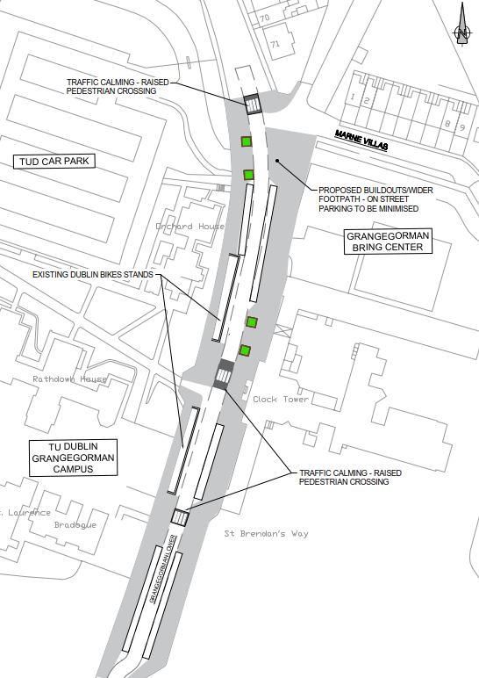

This option involves installing traffic calming measures such as ramps, buildouts, widen footpaths, etc. Additional traffic calming measures would likely reduce traffic speeds, however, the streets would still be dominated by a high volume of motorised traffic using Grangegorman as a cut-through route. It is also worth noting that vacant on-street parking will not result in reduced vehicle speeds. Slower vehicle speeds may be advantageous to cyclists, but less experienced cyclists may not feel comfortable on this shared space. On-street parking would add further potential conflicts to cyclists. Therefore, this option was no longer considered as a viable alternative

### Option 4

Install pedestrian crossings or stop/go system.

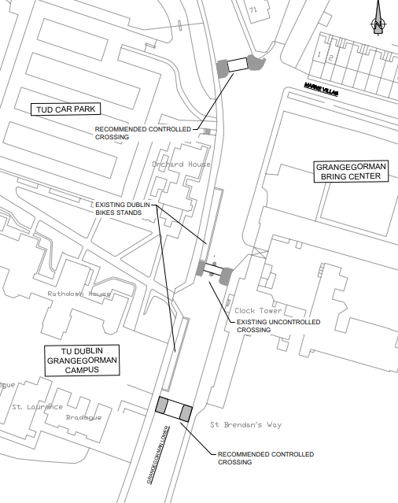

This option involves the installation of two signal controlled crossings. Signal controlled crossings would not be effective at achieving one of the main positives of the trial i.e. to eliminate cut-through traffic.

However, two pedestrian crossings are being implemented by Dublin City Council on Grangegorman Lower to better facilitate safer pedestrian crossing movements. The signals are scheduled to become operational in the coming weeks.

The Grangegorman Development Agency have also stated that these crossings will complement the traffic filtering measures. However, as signal crossings perform a separate and distinct function to filtered permeability, they would not provide a suitable alternative or replacement for such measures.

### Option 5 & 6:

Make Grangegorman Lower a one-way northbound / southbound road.

These options would be a similar to Option 3, with wider footpaths and a one lane carriageway section. This option would not be considered suitable to facilitate the safe movement of pedestrians travelling east to west (and vice-versa) on Grangegorman Lower.

One-way streets can result in higher vehicle speeds, as the perceived risk from oncoming traffic would be removed. Speed surveys conducted in Nov 2017 have indicated that the 85th percentile speeds to be 60km/h, which is twice the 30km/h posted speed limit. Therefore, these options would not be effective at achieving one of the main positives of the trial; to reduce excessive vehicle speeds.

To avoid disrupting cycle networks, “contra flow” cycle lane arrangements would be required, but are far less cycle-friendly than two-way streets with filtered permeability measures. The introduction of two-way cycle lanes could be an option; however, there will be significant risk of conflict with cyclists near the Bring Centre, Marne Villas and the various accesses at this location.

Therefore, these options were no longer considered as viable alternatives.

# Appendix D

## Consultation Letters

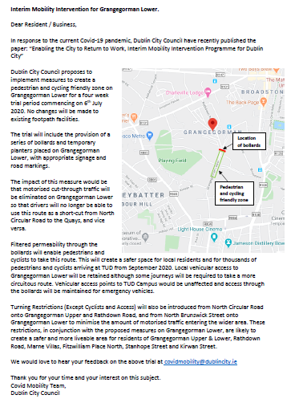

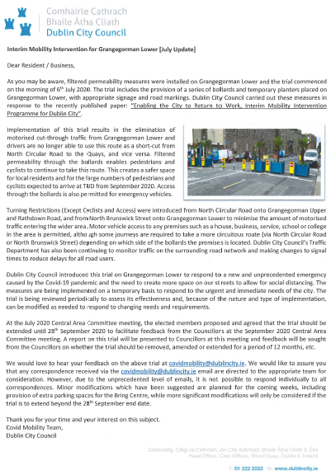

# Appendix E

## Twitter & Facebook Posts And Statistics

### Twitter

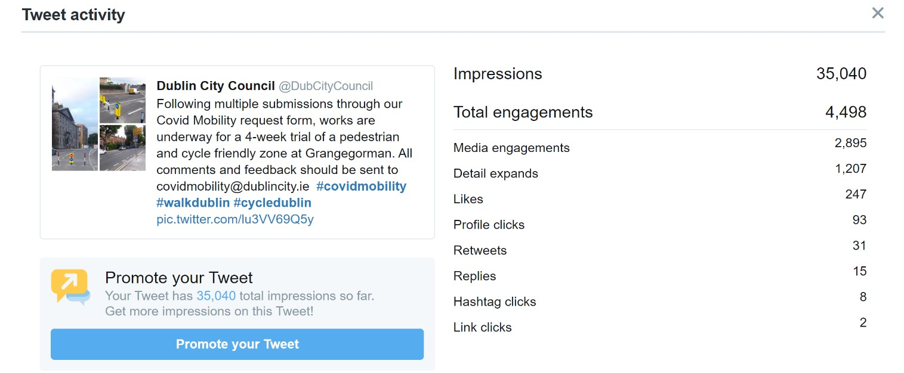

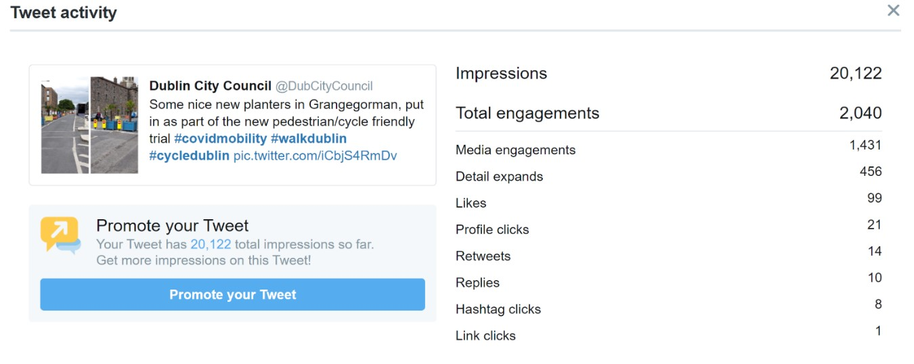

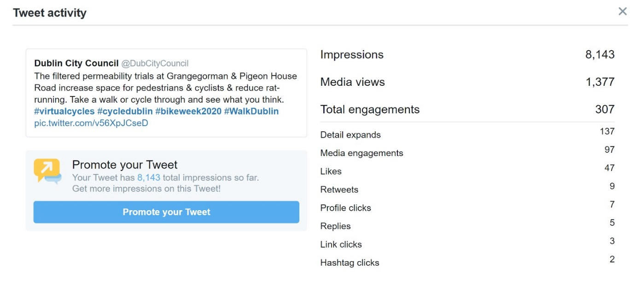

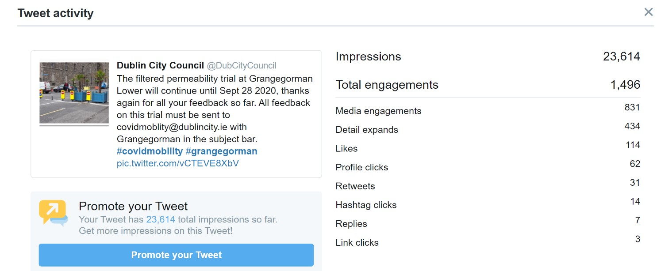

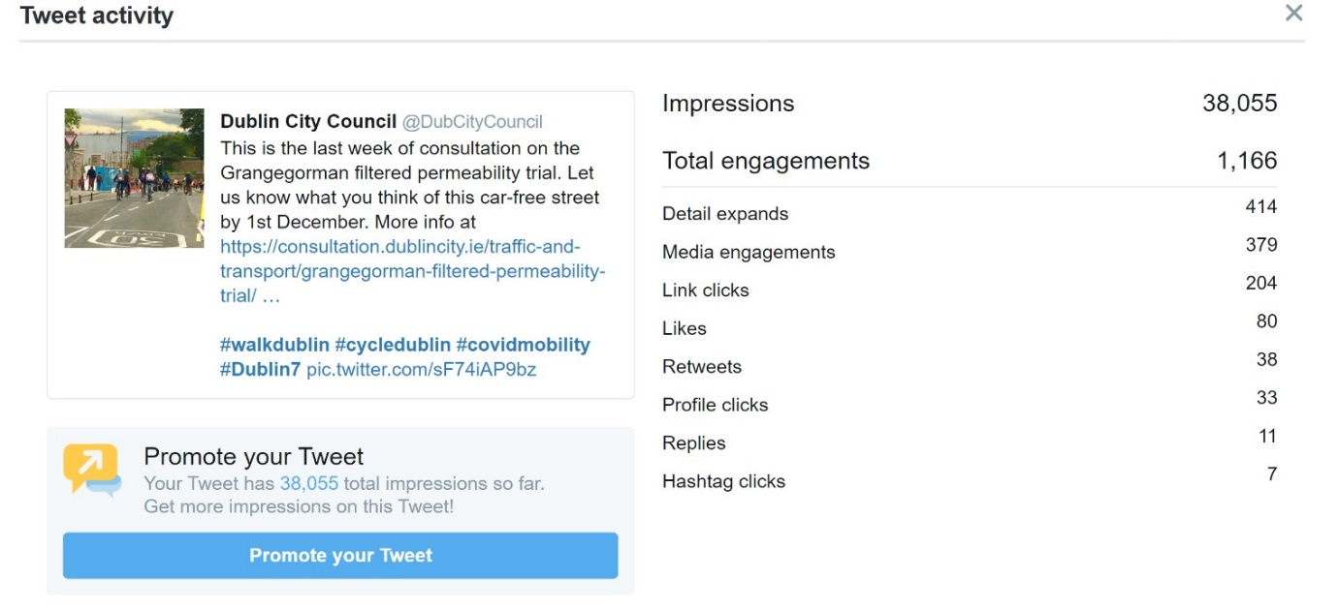

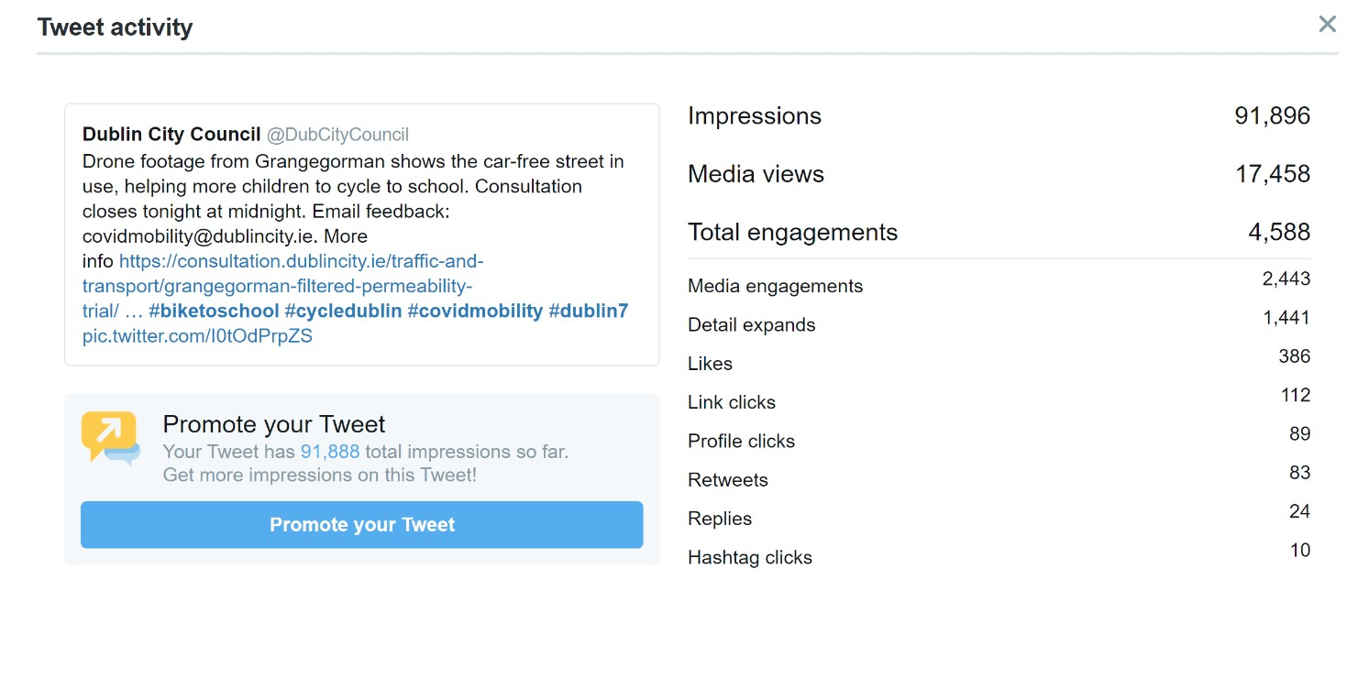

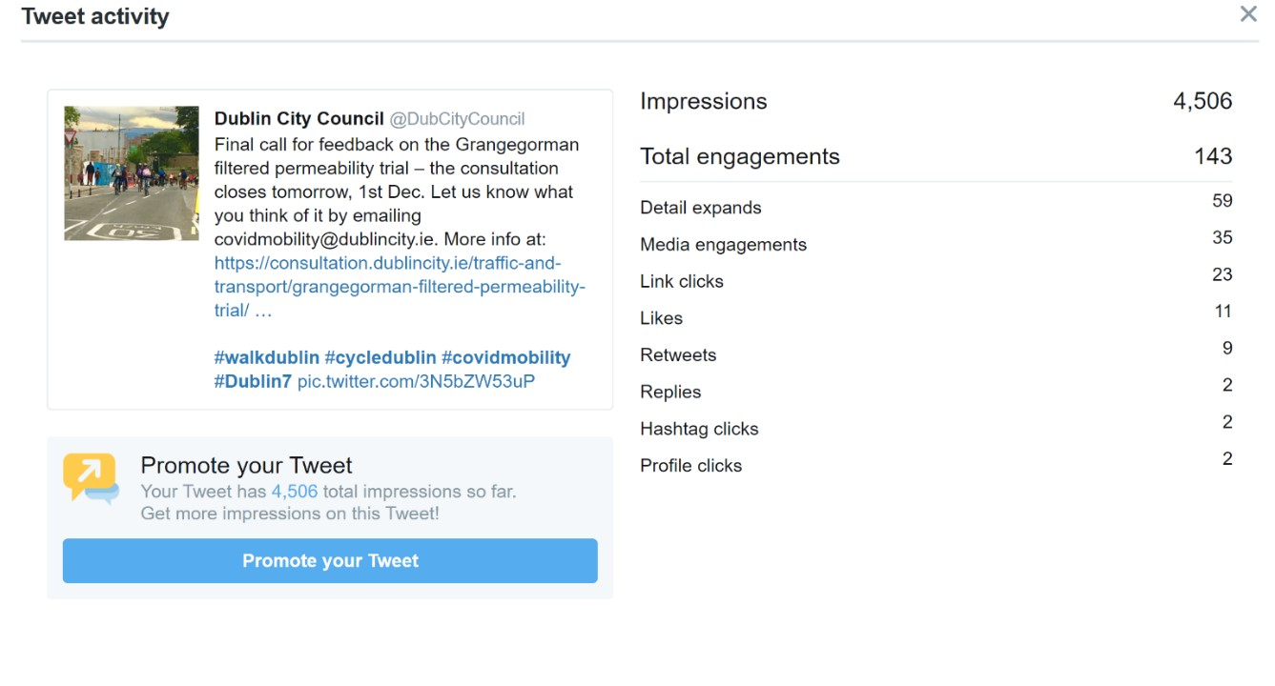

### Facebook

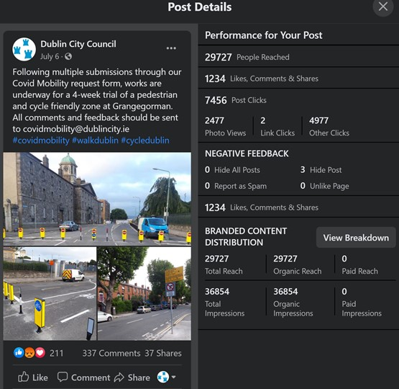

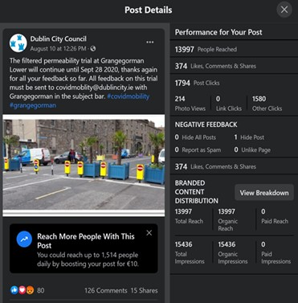

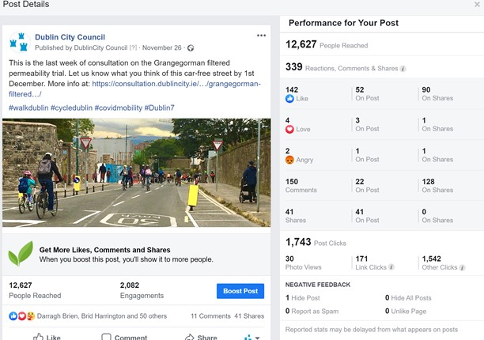

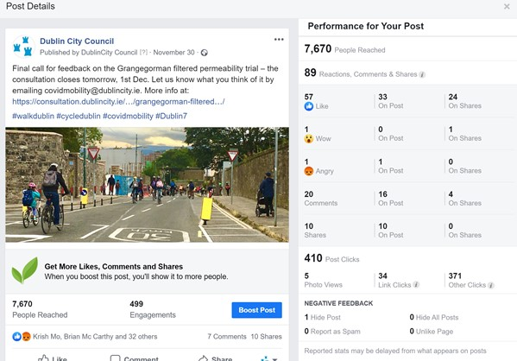

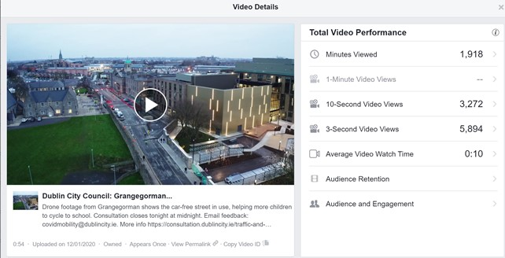

# Appendix F

## Collisions

The RSA database of traffic accidents was examined to establish if there are any existing safety issues in the study area that were not evident from site visits. The database provides accident records for the period 2005 to 2016, with the table below outlining collision types over the eleven year period. One fatal collision and seven minor collisions were recorded in the study area during this period. Further information is provided in the ‘notes’ column in the table below.

|  |  |  |  |  |
| --- | --- | --- | --- | --- |
| **Street Name** | **Fatal** | **Serious** | **Minor** | **Notes** |
| Grangegorman Lower | 0 | 0 | 4 | One minor accident occurred in 2014 (between 3am-7am) near the Grangegorman Lower / Grangegorman Upper junction involving a motor cycle.  One minor accident occurred in 2009 (between 10am-4pm) near the Grangegorman Lower / Grangegorman Upper junction involving two motor cars.  One minor accident occurred in 2009 (between 11pm-3am) near the Grangegorman Lower / Stanhope Street junction involving a bus and a pedestrian.  One minor accident occurred in 2006 (between 7am-10am) near the Grangegorman Lower / Grangegorman Upper junction involving a motor car. |
| Kirwan Street / Manor Street junction | 1 | 0 | 3 | One fatal accident occurred in 2014 (between 7am-10am) at the Kirwan Street / Manor Street junction involving a pedestrian and a bus.  One fatal accident occurred in 2014 (between 7am-10am) at the Kirwan Street / Manor Street junction involving two motor cars.  One minor accident occurred in 2007 (between 7am-10am) at the Kirwan Street / Manor Street junction involving a cyclist and a car.  One minor accident occurred in 2005 (between 7am-10am) at the Kirwan Street / Manor Street junction involving a pedestrian and a motor car.  One minor accident occurred in 2007 (between 7am-10am) at the Kirwan Street / Manor Street junction involving a cyclist and a car. |

# Appendix G additional comments captured from schools surveys

|  |  |  |  |
| --- | --- | --- | --- |
| **D7 Educate Together** | | | |
|  | **Category** | **Comments** | **Number of pupils** |
| POSITIVE | Safety | It is better because you won't get noht nown. (knocked down?) | 24 |
| It's a lot safer. |
| I think it is good and safe. |
| It's a lot safer and easier to use. |
| It's safer and easier when I cycle. |
| It stopped my anxiety of car doors opening. |
| I think the car-free street is great because it is safer for the little kids to cycle. |
| Very awesome, makes it safer to go to school. |
| It's the best, my road is much less busy and safer. |
| It's much safer. |
| It's much safer. |
| I think it is a lot safer. |
| It's great and it's safe. |
| I think it's great and much safer. |
| I think that it became much safer. |
| It's much safer and I love it. |
| It's more safe. |
| I think it's better because it's more safe for children. |
| It's safer for kids walking to school and back. |
| It's very safe. |
| It's a lot safer. |
| It's safer. |
| It's much safer. |
| I prefer it and it's more safe. |
| Impact on journey | I like it. Easier to cycle (x2) | 16 |
| Easier to cycle x3 |
| I think it's good because it's easier to get to school. |
| I think it is better and easier to get to school. |
| It makes it easier when cycling to school. |
| I like it. It helps me when cycling. |
| I really like it. It makes it easier. Me and my family can walk on the road. It's so safe and all the plants are so pretty. |
| I like it because I get to walk home on my own. |
| I really enjoy the scoot to school, there are less cars which makes it easier to get down to school on time. |
| I think it helps with cycling a lot. It makes it easier to cycle. |
| It's much better to cycle on. |
| I find it a lot easier to get to school now. |
| It's easier for me. |
| General / Other | I think there's more bikes on the road. | 85 |
| I think it's amazing and really fun. |
| I think it's much better. |
| I like it (x22) |
| I think it is great. |
| I think it is good (x13) |
| I think it is good because there are less cars. |
| I like the way there's a lot less people. |
| It's calm and I like it. |
| Better. |
| I like it because there is room. |
| It is brilliant. |
| Good. No cars. |
| It is nice (x5) |
| I think it is much better. |
| It's a lot better |
| I think it's great! |
| Like palm trees. Like the colours. |
| It's much less crazy. |
| The best! |
| It's very helpful. |
| I like not having to wait for cars. |
| I have actually only used it a few times, but I think it's better for the school's health. |
| I think it is great!!! |
| I think it's great because kids can cycle down. |
| I think it's decent. |
| It's amazing! (x6) |
| Great (x3) |
| It's good I guess. |
| I think it is nice because it's quieter. |
| I think it’s great. |
| I prefer it to a car filled street. |
| It's a thoughtful thing but cars still come and go still. |
| I don't come from that way but it's still good. Less traffic. |
| I really like it as I cycle. |
| I really like it. |
| It's cool. |
| It is a good idea. |
| I love it. |
| I think it's great! |
| I think it's better. |
| NEGATIVE | Impact on journey | I think they should be taken away for students that come by car. | 4 |
| It's hard to get to school. |
| I don't like dodging the bollards. (cyclist) |
| We need to go that way if it's raining so they should allow cars. |
| General / Other | Not the best. | 5 |
| I don't really like it. |
| I don't like it. |
| Not much space. |
| It's bad. |
| NEUTRAL / MIXED | Impact on journey | I think it's safer for bikesr but it makes it harder to get to school. We found a new route to school which makes it a little bit quicker. I am starting to cycle to school which is fun. | 5 |
| It's good when you cycle but when we drive it is annoying because it takes up the way. |
| It's fine but can be annoying when driving. |
| I cycle because the road got bloacked off. |
| It's good when I cycle but not when I'm late and need to use the car. |
| Safety | It's much better and quiet and safe, thought the stretchy bollards don't work. | 2 |
| I think it makes it safer but must be a bit annoying for cars. |
| General / Other | Well, I only used it once. I don't really mind. | 18 |
| It doesn't affect me but it might affect other people. |
| It makes no difference (x2) |
| I do think that there should be a way for cars to access it easily too though. |
| It is good but sometimes it effects me. |
| It's ok (x4) |
| I'm fine with it. |
| I think it is fine. |
| It is good for bikers but bad for cars. |
| No different, I didn't think it was busy before. |
| It doesn't make a difference to me. |
| Fine. |
| I don't mind it. I like cycling on the road. |
| I like it but not waiting in the car. |

|  |  |  |  |
| --- | --- | --- | --- |
| **St. Pauls** | | | |
|  | **Category** | **Comments** | **No. of students** |
| POSITIVE | Safety | Much safer. | 3 |
| You are not going to get run over. |
| It's helpful cause you don't have to worry about a car. |
| Impact on journey | Easier to walk. | 7 |
| It's easier to walk to the walk way at Constitution Hill. |
| Good way to get different places. |
| I think it's great for walking to school. |
| Good, better for cycling. |
| I think it's easier to get around the whole place. |
| It's good for cycling. |
| Environment | I think it’s great cause it's better for the earth. | 1 |
| General / Other | It's better because you can get more people on the road. | 11 |
| It's alright, it does help. |
| I like it, I think it's nice. |
| Useful. |
| It's alright. |
| It's good. |
| It's good. |
| It would be good for a least / dad |
| It's very good. |
| I think it's good because it's a park and most people go in by car. |
| Great |
| Look & Feel | It feels quieter and relaxed. | 7 |
| It's not as noisy or with cars flying down it. |
| Looks and feels a bit nicer. |
| It's very different, makes the place a lot quieter. |
| I don't really have a problem with the cars but it would be more quiet for the students. |
| Pleasing, makes regular people have a (?) light walk |
| Very quiet. |
| NEGATIVE | Impact on journey | Stupid, can't get to school quicker in the morning. | 1 |
| General / Other | It is bad. | 5 |
| It causes problems for people using TU Dublin grounds. |
| It's dumb. |
| I think it's a bad decision. No real reason for it being car-free. |
| Lethal. |
| NEUTRAL / MIXED | Impact on journey | It's good but I'm annoyed because it would have been a quicker way for me getting to school if it wasn't car-free. | 1 |
| Look & Feel | It feels odd to see no cars going down because I'm so used to it. | 1 |
| General / Other | I do not like it but I understand the reason for it. | 3 |
| It's good and bad. |
| I didn't even notice |

|  |  |  |  |
| --- | --- | --- | --- |
| **Stanhope Primary School** | | | |
|  | **Category** | **Comments** | **Number of children** |
| POSITIVE | Safety | It's much more relaxing and safe. | 2 |
| It's safer. |
| Impact on journey | Since it is close to school it is very easy to drop the kids. | 2 |
| I think it's a really good street. It's a really quick way to get to my school. |
| General / Other | Great. | 1 |
| NEGATIVE | Impact on journey | When raining it's a much longer journey in car and traffic is much worse on Manor Street. | 3 |
| I can't really go to school as fast. |
| Bad, it takes us longer to drive to school. |
| General / Other | It's bad. | 2 |
| I think it is very bad because the Educate Together School still cycle and scoot on the pavement when there is cycle lane where cars should go. |
| NEUTRAL / MIXED | General / Other | It was amazing until the traffic came and I was late for school. Also bikes are on the path! :( | 1 |